Final Year Project Report

Office Metaverse


Project Advisor: Main Ahmed Shafiq

University of Management and Technology
C-II Johar Town Lahore Pakistan
Final Approval

- Head of Department ______________________
Department of Informatics & Systems
School of Systems & Technology
UMT Lahore

- Director (Final Year Projects-CS) ______________________
Department of Computer Science.
School of Systems & Technology
UMT Lahore

- Supervisor ______________________
- Department of Informatics & Systems.
- School of Systems & Technology
UMT Lahore

- Co-Supervisor ______________________

Acknowledgment

We would like to express our sincere gratitude to all those who supported us in the successful completion of our project phase1, Office Metaverse: A Real-Time Virtual Workspace for Productivity and Collaboration. Throughout the development journey, we received invaluable guidance and encouragement from our advisors and co-advisors, particularly Mr. Mian Ahmed Shafiq. Their continuous support, motivation, and insightful feedback helped us remain focused and confident during every phase of the project. Their expertise not only guided us in designing a robust and innovative solution but also instilled in us the importance of accuracy, discipline, and critical thinking.
We are also grateful to the members of the Evaluation Committee for their constructive feedback and thoughtful suggestions, which played a vital role in improving the quality and effectiveness of our project. This project proved to be a significant learning experience, strengthening our understanding of both technical implementation and real-world problem solving. Through Office Metaverse, we gained deeper insight into modern collaborative systems and virtual work environments, highlighting their growing importance and positive impact on productivity and society as a whole.

Project Title Office Metaverse: A Real-Time Virtual Workspace for Productivity and Collaboration.
Objective
The objective of Office Metaverse is to create a real-time virtual office environment that enhances remote collaboration, productivity tracking, and team presence. It aims to simulate a physical workspace digitally by integrating live interaction, activity monitoring, and AI-assisted insights to improve work efficiency and accountability.

Undertaken by
- Muhammad Saad Ali(F2022266790)
- Saffi Sardar(F2022266742)
- Mian Muhammad Haris Nadeem(F2022266718)
- Marukh (F2022266711)

Supervised by: Mr. Mian Ahmed Shafiq
Starting Date: October 2025

Completion Date: (to be added later)

Tools Used: VS-Code, Python, Postman, TablePlus, Figma, Github, etc.
Operating System: Windows, Mac

Abstract
Office Metaverse is a real-time virtual office platform developed to address the growing challenges of remote and hybrid work environments by digitally replicating the structure, interaction, and accountability of a physical workplace. The system provides a shared virtual space where users are represented through avatars, enabling live presence awareness, movement-based interaction, and seamless communication among team members. This environment encourages collaboration and engagement while maintaining a sense of co-location that is often missing in traditional remote work tools.
The platform integrates real-time communication infrastructure, task and activity tracking, and productivity analytics to monitor work patterns and performance in a non-intrusive manner. Users can join virtual rooms, collaborate on tasks, and participate in meetings while their activity data contributes to meaningful insights for both individuals and managers. AI-assisted productivity features analyze user behavior, task completion trends, and engagement levels to provide recommendations that help optimize workflow and improve efficiency.
Office Metaverse is designed with scalability, security, and extensibility in mind, making it suitable for small teams as well as large organizations. By combining real-time systems, analytics, and intelligent assistance within an interactive virtual workspace, the project bridges the gap between physical offices and digital collaboration tools. Ultimately, Office Metaverse aims to enhance productivity, transparency, and team cohesion, offering a modern solution for the evolving future of work.
Revision Chart

Version | Primary Author(s) | Description of Version | Date Completed
1.0 | Muhammad Saad Ali  (F2022266790)  Saffi Sardar  (F2022266742)  Mian Muhammad Haris Nadeem  (F2022266718)  Marukh  (F2022266711) | This is the completed draft of the first capstone project. There are a total of 5 chapters.  1. Introduction  2. Domain analysis  3. Requirement Analysis  4. Data Flow Diagram  5. System Design | 2/3/2026

Contents

Contents 7
Introduction 8
1.1 Motivations 8
1.2 Project Overview 8
Problem or Overview Statement 8
1.3 Problem Statement 12
1.4 Objectives 13
2. Domain Analysis 14
2.1 Customer 14
2.2 Stakeholders 14
Stakeholders and Their Roles in the System 14
2.3 Affected Groups with social or economic impact 15
2.3.1 Organizations / Remote Teams (Customers) 15
2.3.2 Team Members / Developers / Employees 15
2.3.3 Managers / Project Leads 16
2.4 Dependencies/ External Systems 17
2.5 Reference Documents 18
2.5.1 Related Projects 18
Related Projects 18
2.5.2 Feature Comparison 20
3. Requirements analysis 21
3.1 Requirements 21
3.2 List of Actors 26
3.3 List of use cases 27
3.4 System use case diagram 29
3.5 Extended use cases 30
3.6 User interfaces (mock screens) 65
4. Data flow diagram (optional) 66
4.1 Data Flow Diagram Level 0 66
4.2 Data Flow Diagram Level 1 66
4.3 Data Flow Diagram Level 2 67
5. System Design 68
5.1 System Architecture Diagram 68
5.2 Class Diagram 69
5.3 Sequence Diagrams 70
5.4 Collaboration Diagrams 71
5.5 Other UMLs 73
5.6 ERD 74
5.7 Data Dictionary 75

Introduction

Motivations
The motivation behind developing Office Metaverse has arisen from the constant shift towards remote and hybrid work environments, where teams often faced an issue with limited real-time interaction, inconsistent communication, and insufficient visibility into employee productivity. As there are still existing platforms like Zoom, Slack, and Gather.town that offer partial solutions, they’ve failed to provide a unified space that combines virtual presence, task management, and AI-driven analytics in an engaging way. As organizations increasingly depend on distributed teams, the need for a collaborative workspace that replicates the transparency, coordination, and structure of a physical office becomes essential. Office Metaverse aims to address these gaps by creating an immersive 2D virtual environment that brings teams together, enhances productivity tracking, streamlines agile workflows, and provides a data-driven approach to managing distributed teams. This project is motivated by the vision to improve remote work culture, eliminate switching tools , and offer organizations a more interactive, efficient, and cost-effective alternative to office setups.

Project Overview
Office Metaverse is a real-time virtual workspace designed to enhance remote collaboration, productivity monitoring, and team presence by simulating an interactive office environment. Instead of traditional video calls and messaging tools that lack immersion and team visibility, Office Metaverse enables teams to work together in a shared 2d space where users are represented by customizable avatars and can interact spontaneously, similar to real office.
The platform integrates Real-time communication, activity tracking, AI-powered productivity insights, and environment-aware collaboration features. Users can move around the virtual office, join meetings by walking into meeting rooms, collaborate on shared productivity boards, engage in focus or breakout zones, and recive personalized assistance from an integrated AI productivity agent. The goal is to reduce digital isolation, improve workflow coordination, and bring back the sense of presence that remote work environments lack.

Problem or Overview Statement
Traditional remote work setups rely heavily on Slack, Zoom, MS Teams and Trello, which provide communication and task management but fails to replicate real presence, spontaneous teamwork, and natural interactions. Remote members often feel isolated, struggle with coordination delays, and lack visibility into who working, available, busy, or collaborating. This leads to reduce engagement, lower productivity, and weaker team culture overtime.
Office Metaverse addresses these issues by transforming remote workflow into shared spatial experience where presence and collaboration feel more natural. Through real-time avatar intraction, proximity-based voice/video chat, workspace layout awareness, analytics dashboards, and AI assisted productivity recommendations, the system strengthens teamwork and improves efficiency without sacrificing the flexibility of remote work.

Customers
The primary users of Office Metaverse includes:
- Remote and Hybrid Teams who requires seamless day-to-day communication and collaboration.
- Startups and Software Houses looking to maintain strong team culture across distributed environments.
- Educational institutions & Virtual Classrooms that needs interactive learning spaces.
- Enterprise with Global Teams requiring a centralized workspace for cross-time-zones coordination.
These users benefits from improved collabaration, reduced communication friction, social presence, real-time awareness of team activities, and integrated productivity insights that help track work progress effectively.

Goals
- Enhanced Team Collaboration And Productivity:
Our Ultimate Goal for this Product is to help gain maximum gainable productivity from the employees, with this collaborative product employees/teams will be able to communicate and sync their work with pears seamlessly with just one click, giving them full control from their finger length. Because of transparency, work won't be delayed and gain high productivity.
- AI-Assisted Task Management:
We aim to provide the scrum master full liberty to take assistance from an AI assistance model in assigning tasks to the relevant employees automatically without wasting time on this cumbersome burden and instead planning the future sprints and backlogs.
- Productivity Monitoring & Analytics:
At the end of every day, the scrum lead/master and managers will be provided with analytical monitoring data which will provide how well the day was spent in terms of productivity and how many tasks got completed/progressed and a future prediction for future sprints estimated time too.

- Interactive & Engaging Virtual Workspace:
With the help of Real time websocketing communication, employees will be able to communicate with their team members interactively inside the web app, no need to use third party apps and ruin productivity.
- Integrated Agile Workflow:
We aim to provide a custom Agile Scum Board which the scrum master will be able to interact with, he will be able to conduct all scrum functionality with ease and inside the web app without being dependent on third party agile scrum apps.
- Real-Time Updates:
We try to provide swift real time cross communication updates if network bandwidth allows, one commit through an employee should immediately be updated for the manager, minimizing confusions.

System functions

User Registration & Profile Management:

The System will provide user authentication to provide security and Credential alteration options in case the user fails to remember his credentials. It will also give users the liberty to edit profile settings(Name,Password,Update Role,Update device Syncage and so on).

Virtual Workspace Navigation:

Real-time communication will allow the System to allow users to roam around/navigate/interact with the virtual workspace and its items seamlessly and swiftly. The System will provide functionalities such as hover to view, toggles, auto-follows and much more to provide a fun navigation experience.

AI-Driven Scrum Backlog Management:

The System will be integrated with a custom Scrum Board along with a Task Management AI Assistor in the web app, the user won't need to waste time in third party scrum apps.. The Managerial Staff will be given the authority to interact with this feature. AI will save user time by providing auto task appointment suggestions based on employee skillset and traits in the team.

Real-Time Communication Tools:

The System will provide integrated support of interactive boards, calendars, reminders, voice meeting and video calls plus screen sharing functionality. Moreover it will also provide users the liberty to communicate with pears through proximity features while navigating the space.

AI-Productivity & Activity Tracking:

The System will implement AI models to predict time required to complete future sprints using past records of worker performance as dataset, it will also provide daily analytics based on how well the workers performed throughout the day, and how many prs.

Virtual Office Map expansion:

The System will have the ability to automatically and dynamically increase office map size in case the users exceed the map space because of new hirees, this all will be done automatically so the user can focus on matters that matter

Live-Halting-Alerts:

The System will conduct live-summon abilities, speedy alerts will be communicated to any user if they are needed immediately or certain work is needed from them, their tasks and everything will be freezed and only allowed to perform the immediate task, nothing else will be accessible on their dashboard so they know the significance of the task.

System Attributes:
Scalability: Cloud-based architecture (AWS/Firebase) supports horizontal scaling for concurrent multi-user rooms and real-time interactions.
Reliability: Distributed real-time infrastructure using WebSockets and fallback-based failover ensures consistent presence and uninterrupted communication.
Performance: Optimized event-driven communication powered by WebSockets / WebRTC and state synchronization techniques ensures smooth multi-user interactions.
Security: Role-based access control (RBAC), JWT authentication, end-to-end encrypted communication channels, CORS policies, and secure user workspace boundaries.
Usability: Intuitive drag-and-move avatars, click-to interact rooms, integrated task dashboards, and contest-aware UI for seamless workflow navigation
Flexibility: Customizable avatars, interactive rooms (Meeting Room, Break Room, Focus Pods), adjustable workspace visibility, and plugin-based feature expansion.
Real-Time Capabilities: WebSockets and WebRTC enable real-time presence, voice chat screen-sharing, activity status updates, and synchronized collaboration boards.
Maintainability: Modular microservice architecture with CI/CD pipelines (Github / Docker) ensures easy updates, rollout of new features, and reduced deployment downtime.
Interoperability: Integration with Google Calendar, Eraser.io, Github for project tracking, and LLM-based AI productivity agents.
Customizability: Users can design their own avatars, can create custom boards that embed sites like Google Calendar or Eraser.io.
Data Integrity: Consistent, validated, encrypted data storage using Postgres SQL with SQl alchemy integration providing role-based controlled access and immutable activity logs.
Support & Documentation: Interactive onboarding tutorial, User guidelines, AI chatbot assistance, team helpdesk, and community support channels for trouble-shooting.

Problem Statement
Recently remote and hybrid workmodels are gaining immense popularity. The pandemic in 2019 highlighted the need for some sort of online platform to continue daily office routines and hastened development in online work models. Platforms like zoom and slack existed to conduct meetings and maintain workflow. Gather.town was created in 2020 during covid-19 as a more interactive way for communicating in an online workplace.
However, these platforms lack the ability to detect real time presence. It compromises awareness and communication amongst the team members. Monitoring productivity and engagement, evaluating each individual becomes extremely difficult. Tools for integrating task management and performance analytics are limited.
Thus, using any of these platforms still will require some sort of external setup to full fill those limitations and maintain a cohesive, interactive and data driven work-culture remote setup
To overcome these problems Office Metaverse allows users to collaborate in an immersive 2D environment. Each user is an avatar and is assigned a role according to which the user can interact using real time chat, movement and collaboration zones(meeting rooms, project boards, etc). Office Metaverse uses AI driven monitoring, task tracking and employee analytics. This ensures transparency in the workspace and assists the managerial staff to be informed about each individual employee. Task assignment on integrated agile model, keeps the team organized and any change is automatically visible to all. Since members don't have to hop between interfaces for checking their tasks and interrupting workflow. This interactive and playful environment will increase productivity. For organizations using the roles (assigned to each avatar) they can integrate a hierarchy system. Gain productivity and a real office environment increasing profitability and workspeed.

Objectives
- Ai model capable of creating,managing updating the scrum backlog
- Productivity analysis through work analytics and activity tracking
- Automated task assignment according to Productivity analysis
- Role Based access to the workspace
- Communication tools like chat,voice/video call
- 2D virtual space

Domain Analysis

Customer
The customers of Office Metaverse are organizations, teams and companies that are there to manage the remote and hybrid work environment more effectively. A virtual workspace can be set up for businesses and organizations can register through the platform. An optional premium subscription plan can be offered for advanced analytics, larger virtual spaces, or enterprise-grade features, also teams can set up freely.

Stakeholders
Table 2: List of Stakeholders

Stakeholders and Their Roles in the System
Stake Holders | Roles in System
Organizations/ End Businesses | Organizations will be setting up their virtual office environment , they will be assigning roles (admin , manager , member) and utilize features such as task boards, meeting rooms , productivity analytics and real-time collaboration tools. They will be managing teams , monitor performance and configure workspace settings.
Managers / Project Leads | Managers will be monitoring productivity metrics, they will be assigning tasks via scrum board, Activity tracking, virtual meetings set-up and ensuring smooth workflow between teams.They create communication and maintain alignment with organizational goals.
Teams members / Developers | The collaboration between team members will be through virtual workspace, Avatar based representation, move between zones, work on assigned tasks , progress updation, communication through chats and meetings,utilization of AI-assisted backlog and task suggestion.
System Admin | The platform infrastructure will managed through system admins , permissions, subscription packages, user accounts , and ensuring system reliability, real-time communication,security and over-all workspace maintenance
Table 2: list of stakeholders

Affected Groups with social or economic impact

2.3.1 Organizations / Remote Teams (Customers)
Social Impact:
- Reduces isolation by providing a virtual and engaging environment for the employees to connect even in remote teams
- Assures realtime presence of the employees increasing collaboration and over all team communication
- It recreates the real office environment through avatars,collaborative zones , meetings and role assignment to develop a hierarchy system.
Economic Impact:
- Saves cost on rent and infrastructure
- Increased productivity through AI task management, analytics and reduced workflow fragmentation
- Provides all collaboration tools necessary as a unified system saving time for users tool hopping according to their collaborative needs

2.3.2 Team Members / Developers / Employees
Social Impact:
- Provides Interactive and engaging environment for employees to feel more connected
- Minimizes communication gaps, there is complete transparency and everyone is aware of their tasks/work assigned
- Boosts employee confidence and over all morale towards work

Economic Impact:
- Productivity of each employee can be measured therefore developing a sense of responsibility towards the job.
- Providing one unified platform saves time meaning the employees give full time to the task at hand instead of waiting around or checking for instructions
- Since performance analytics of each employee is available it will improve their career and benefit them for future jobs/interviews.

2.3.3 Managers / Project Leads
Social Impact:
- Increases leadership communication since every single employee has to be present for the meetings
- Easier to coordinate with employees through scrum dashboard and virtual meeting rooms.
- Decision making is easier because of available work analytics
Economic Impact:
- Since reports,task management and individuals analytics are available it makes the managers life way easier
- Clear tracking system and coordination facilitates meeting deadlines for projects
- Resource management becomes easier and makes a more cost effective approach towards the projects.

Dependencies/ External Systems
The Office Metaverse depends on several external tools, APIs, and services to function smoothly. These systems provide authentication, AI capabilities, real-time communication, rendering, and cloud infrastructure support.
1. MojoAuth (Passwordless Authentication)
Used for secure user login and identity verification. Provides OTP-based access, eliminating the need for traditional passwords and reducing security risks.
2. OpenAI + LangChain (AI Services)
Handles AI-driven features such as summarizing meetings, generating reports, answering user queries inside the metaverse, and powering smart automation within the backend.
3. Google Calendar API (Event Sync)
Allows the platform to sync scheduled meetings, send upcoming event reminders, and show calendar pop-ups directly inside the virtual workspace.
4. WebSockets / Socket.IO (Real-Time Communication)
Enables instant updates for user movement, presence tracking, chat messages, notifications, and collaborative interactions across the 2D environment.
5. Pixi.js (2D Rendering Engine)
Responsible for rendering the virtual office map, avatars, rooms, animations, and interactive elements in the metaverse interface.
6. FastAPI (Backend Framework)
Provides the core backend services such as REST APIs, authentication flow, AI routing, workspace logic, and data processing operations.
7. PostgreSQL (Primary Database)
Stores user profiles, room configurations, tasks, logs, workspace states, and historical activity data. Ensures reliable, ACID-compliant storage.
8. Docker + GitHub Integration (Deployment & Version Control)
Used for containerizing backend services, maintaining clean deployments, automated builds, and syncing development work across the team with proper version control.

9. Cloud Hosting Service (AWS / Render / Railway)
Hosts backend services, WebSocket servers, and the database. Ensures high availability, scaling, and monitoring of system performance during peak loads.
10. Logging & Monitoring Tools (Grafana / CloudWatch / ELK Stack)
Tracks performance, errors, unusual activity, and system health to maintain reliability and stability as users interact in real time.

Reference Documents

Related Projects

Related Projects
1. Gather.town (https://www.gather.town/?utm_source=chatgpt.com)
Purpose: A 2D virtual office platform that supports avatar movement, proximity-based video chat, meetings, and interactive spaces.
Examples: Gather Town for offices, events, classrooms.
Relevance: Good for social presence and communication, but limited in advanced productivity tools, analytics, and developer-oriented workflows.
https://www.gather.town/features?utm_source=chatgpt.com
https://www.gather.town/blog?utm_source=chatgpt.com https://github.com/orgs/gathertown/repositories?utm_source=chatgpt.com
2. WorkAdventure (https://workadventu.re/?utm_source=chatgpt.com)
Purpose: A self-hostable 2D virtual workspace engine with customizable maps and real-time interaction.
Examples: WorkAdventure GitHub project, community self-hosted servers.
Relevance: Strong reference for architecture and WebRTC/WebSocket real-time features; ideal for studying open-source implementation details. https://github.com/workadventure/workadventure?utm_source=chatgpt.com
3. Kumospace (https://www.kumospace.com/ )
Purpose: Virtual office with spatial video chat, rooms, and team spaces.
Examples: Kumospace remote teams & meeting spaces.
Relevance: Provides clean UI and team workspace features but less customization and fewer technical integrations than your proposed system. https://www.kumospace.com/blog/gather-town-alternatives?utm_source=chatgpt.com https://en.wikipedia.org/wiki/Kumospace?utm_source=chatgpt.com
4. HyHyve / Lightweight Virtual Spaces
(https://www.hyhyve.com/?utm_source=chatgpt.com )
Purpose: Simplified interactive spaces for meetings, events, and workshops.
Examples: HyHyve interactive spaces.
Relevance: Good for lightweight usage; lacks advanced office features, AI tools, task management, and analytics. https://www.hyhyve.com/workadventure-alternative/?utm_source=chatgpt.com https://www.hyhyve.com/solution/hybrid-workspace/?utm_source=chatgpt.com

Feature Comparison
Feature / System | Gather.town | WorkAdventure | Kumospace | Our Office Metaverse (Proposed System)
Primary Focus | Virtual office & social interaction | Open source 2D workspace engine | Team meetings & spatial video chat | Full office ecosystem with AI, productivity & analytics
Real-Time Interaction | Yes | Yes | Yes | Yes (enhanced with AI presence)
Customization | Moderate | High (open source) | Low - Moderate | High (custom boards + templates)
Self-Hosting | No | Yes | No | Yes
Team Productivity Tools | Limited | Minimal | Limited | Extensive (tasks, code panel, dashboards)
AI Assistance | No | No | No | Yes (productivity analytics, smart suggestions)
Meeting Tools | Basic video rooms | Basic rooms | Enhanced spatial calls | AI notes, auto-attendance, smart meeting tools
Developer Tool Integration | No | No | No | Yes (GitHub, CI/CD, code editor)
Cost | Subscription-based | Free (open source) | Subscription-based | Free / self-hosted

Requirements analysis

Requirements

Category | Description
Non-Functional Requirements | Real-time Avatar Latency:  NFR-1: The system has to synchronize avatar movements and state changes (active, idle, entering rooms) over all clients under 200ms to maintain the "live" feel of the virtual workspace.
UI Responsiveness (Hover Interactions):
NFR-2: Task details and progress status must be recovered and displayed in 300ms of a user staying over an interactive desk or notice board.
High-Frequency Data Handling:
NFR-3: The backend, utilizing FastAPI and Redis, must process up to 30 WebSocket packets per second per user to check smooth movement without jitter.
Strict Role-Based Access Control (RBAC):
NFR-4: The system must execute binary access levels; only users with the "Manager" role can enter the analytics dashboard and create/assign tasks, while "Employees" are not allowed to status updates.
Session Security:
NFR-5: User authentication must be directed via JWT tokens with a secure termination policy to protect the "Confidential" nature of the project and internal task data.
Connection Persistence:
NFR-6: The system must automatically aim to reconnect WebSockets in the duration of 2 seconds of a network drop to secure uptime tracking and room presence logging stay accurate.
Graceful AI Degradation:
NFR-7: In case of delays or unavailability of the AI modules like Task Recommendation and Chat assistant, the system must remain functional. Things like task management should be available enough that it does not affect the user experience.
Data Integrity for Analytics:
NFR-8: Logging times of users should be accurately recorded. E.g., Time spent per zone or in the office space in general. Accuracy of time readings is important for.
Data Requirements | Data Requirements  User Data (DR_1):  - Contains role-based account info (Employee/Manager)  - Assigned unique avatar assets.  - Covers login credentials.  Virtual Office Data (DR_2):  - Includes 2D/3D office layouts.  - Coordinates of desk /rooms  - Includes the real-time avatar positions.  Task Management Data (DR_3):  - Covers task descriptions, deadlines.  - Assigned personnel.  - Covers Status (To-do, in progress, Done)  Analytics & Activity Logs (DR_4):  - Logs of uptime  - Logs of idle time  - Time spent per office zone  - Task completion metrics
Constraints | Constraints:  Data Privacy and Security (C_1):  - Covers role-based authorization.  - protected JWT token management to save confidential project data.  Data Integrity (C_2):  - Covers that task progress.  - presence logs are verified by Pydantic to balance consistency.  Data Storage and Backup (C_3):  - Utilizes PostgreSQL for relational data storage.  - Redis for high-speed in-memory data handling.  External System Dependencies (C_4):  - Integrates third-party AI models (OpenAI, LangChain)  - Illustration of libraries (Pixi.js or Three.js)
External interface requirements | Compliance and Legal Interface:  CL_1: The system should save user activity logs and analytics in accordance with standard data protection practices to check the confidentiality of employee tracking data.  CL_2: Data stability policies shall be utilized to uptime, idle time, and room presence logging to validate accurate and legal performance reporting.  Hardware Interface:  HI_1: The system must consult with standard input devices (Mouse and Keyboard) to ease real-time avatar movement and plotting within the virtual office.  HI_2: Real-time visual alerts and notifications related to task updates and presence changes shall be distributed through the web-based graphical dashboard.  User Interface:  UI_1: The virtual workspace must be shown through a dynamic graphical dashboard containing rooms, desks, and responsive elements computed with modern web browsers.  UI_2: The application must give a role-based dashboard where Managers retrieved analytics dashboards and Employees access personal task views.  UI_3: Avatar positions, task statuses (To Do, In Progress, Done), and room presence should be notified in real time without manual page refreshes.  UI_4: An AI-powered chat assistant and collaborative notice boards shall be fully implemented into the virtual environment for in-app support and task details.  Security Interface:  SI_1: JWT-based authentication is compulsory to protect login and session management for both Employees and Managers.  SI_2: Role-Based Access Control (RBAC) must be started to implement proper security clearance for task making and performance analytics based on user roles.  SI_3: All real-time data transmissions via WebSockets and REST API calls should be protected to balance project confidentiality.  API Interface:  API_1: The system should create internal APIs using FastAPI for user registration, task CRUD operations, and presence logging.  API_2: The system should use AI interfaces (OpenAI/LangChain) to provide task recommendations and chat support functionality.  API_3: The frontend should interact with charting libraries like Recharts or Chart.js to retrieve performance metrics and activity conclusion.  Database Interface:  DB_1: The system should include a relational database (PostgreSQL) managed via SQLAlchemy for storing persistent user, task, and log data.  DB_2: An in-memory data store (Redis) must be used to manage high-speed real-time communication states and avatar synchronization.

FUNCTIONAL REQUIREMENT CATEGORY AND ATTRIBUTE TABLE:

# | Description | Category | Attribute | Details & Boundary Constraints | Diagram
1 | Role-Based Registration | User Management | Authentication | Must assist distinct registration flows for "Employee"and "Manager" roles. | 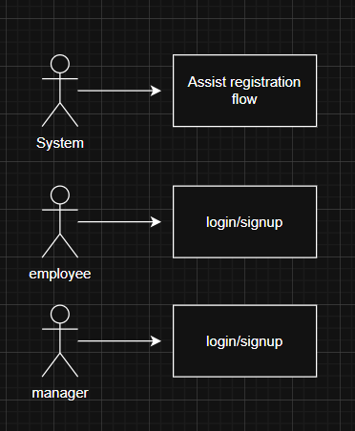
2 | Secure JWT Session | Security | Authorization | The system should issue JWT tokens within login to handle session diligence and secure logout. | 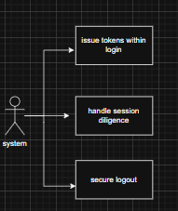
3 | Real-Time Synchronization | Virtual Office | Connectivity | Avatar movements and actions should sync within all clients via WebSockets with minimal latency. | 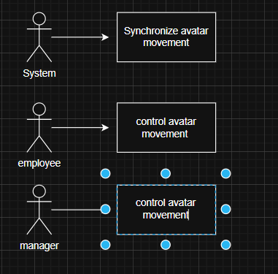
4 | Interactive 2D Environment | Virtual Office | Interface | Must render a 2D map with clickable desks and notice boards for user interaction. | 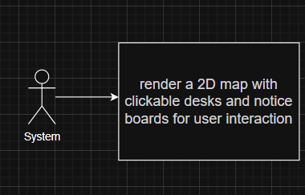
5 | Zone Presence Detection | Activity Tracking | Automation | The system should trigger "entry/exit" events when avatars cross defined room boundaries. | 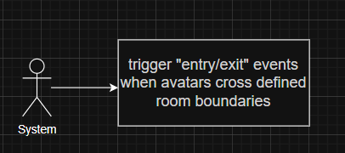
6 | Task Assignment Engine | Task Management | Management | Only users with the "Manager" role can create, assign, and set deadlines for tasks. | 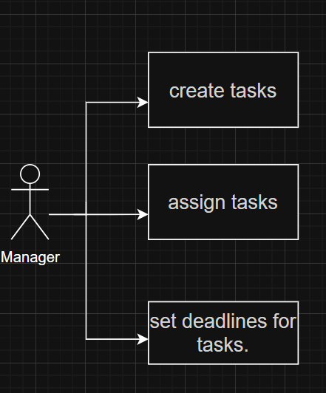
7 | Status Workflow Updates | Task Management | Productivity | Employees must be able to switch task states between "To Do," "In Progress," and "Done". | 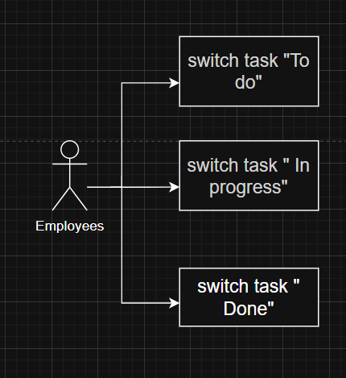
8 | Kanban Visual Board | Task Management | Visualization | Must include a drag-and-drop dashboard with vertical columns for visual workflow management. | 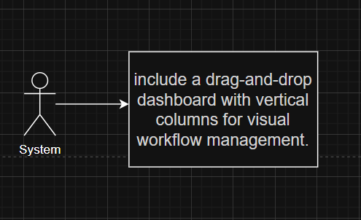
9 | Live Presence Status | Communication | Availability | Must automatically switch status between active, idle (based on inactivity), and offline. | 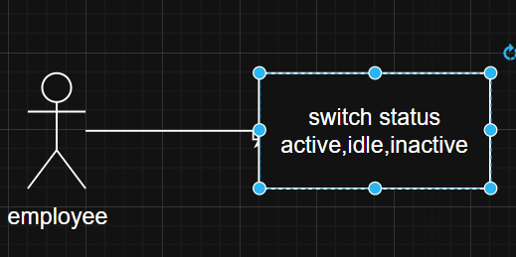
10 | Usage Time Logging | Analytics | Monitoring | The system should log the specific duration of uptime vs. idle time and time spent per zone. | 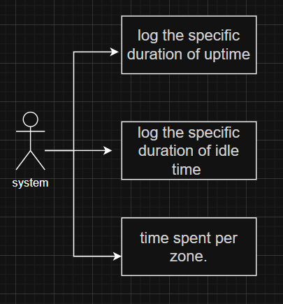
11 | Multimedia Suite | Communication | Collaboration | Should support embedded text chat, voice/video calls, and real-time screen sharing. | 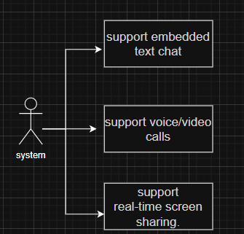
12 | AI Task Prioritization | AI Innovation | Intelligence | AI engines should analyze user history to suggest and prioritize tasks for employees. | 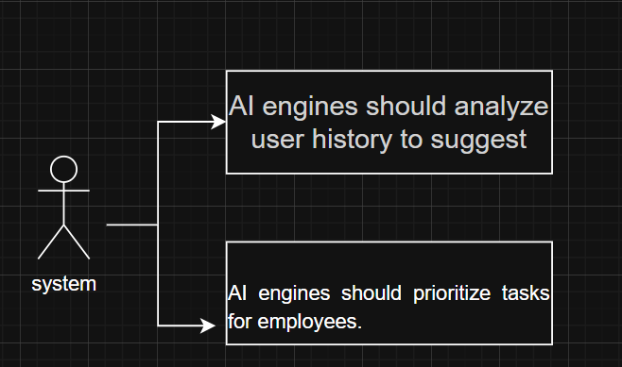
13 | AI Support Assistant | AI Innovation | Support | An in-app bot should answer common user queries and provide feature walkthroughs. | 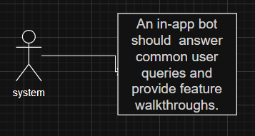

List of Actors
1. Employee : The primary user of the virtual office environment is an employee. They are responsible for maintaining their personal digital availability by styling their unique avatar and searching the 2D office layout to access their designated desk or meeting rooms. Employees engage with the system to view tasks given to them, transform their work status (To Do, In Progress, Done) on the Scrum board, and interact in real-time communication via text, voice, or video calls. They also get help from AI-driven task recommendations based on their behavior and historical data.
2. Manager The Manager overlooks team productivity and coordinates the workflow during the metaverse. While they share basic functionalities with employees, such as avatar movement and communication, they have privileged permissions to create, assign, and set deadlines for tasks. Managers use the analytics dashboard to check daily activity summaries, task completion statistics, and time spent by staff in various office zones. They are responsible for high-level project management using the visual Scrum board and figuring out the productivity metrics.
3. Administrator (Admin) The Admin is accountable for the overall maintenance, security, and configuration of the platform. Although the provided documentation focuses heavily on role-based access for Employees and Managers, the Admin actor is assigned for executing the role-based access control (RBAC) and validating the JWT-based authentication system is secure. They maintain the broader system settings, access uptime and idle time logging, and verify that the virtual office layout and interactive elements are functioning correctly for all users.
4. AI Chat Assistant (System Actor) The AI Chat Assistant is an automated innovation layer within the platform. It is used as a support bot to inform users through the metaverse's features and answer common queries in real-time. As an autonomous actor, it also powers the Task Recommendation Engine by monitoring user behavior to suggest relevant tasks and prioritize workloads for Employees and Managers.

List of use cases
Login: Users access their accounts through desktop clients. After authentication they are spawned into their designated Zone or last known location.
Avatar Customization: New or existing users can design their 2D character representation. Use available accessories and options to customize the character according to their own personal preference.
Manage Presence Status: Users set their availability active/idel. The system uses visual indicator like arrow above user’s avatar head to display their availability status to other users
Enter/Exit Virtual Room: users can move around in the 2D environment between different rooms e.g., Conference Room. The system will activate spatial audio and visibility of elements in the room once the user enters.
Proximity chat: Following real life sound physics. Avatars closer to each other can hear louder than the avatars positioned far apart.
Create Private Zone: Users can create a private meeting room/table.Users are not audible beyond the meeting room/table and outside users will need permission to enter.
Interact with Office Elements: Users can access interactive clickable elements within the room layout, such as desks or notice boards
Room Presence Tracking: The system keeps track of the time the user avatar spends in specific zones or rooms simultaneously logging time duration the user was active.
Create Task: Managers can create new tasks.
Assign Task: Managers allocate tasks to a team or a single user
View Scrum Board: Users access a Kanban-style board to view the visual workflow of all team tasks.
Update Task Status: Employees can change tasks status by using drag and drop functionality for moving tasks from "To Do," to "In Progress," and then "Done" column.
View Task Details: Users can see overview of task information, like deadlines and progress, by hovering their cursor over a task.
Monitor Task Progress: Managers track task status (completed/overdue) in real time for each individual user.
Text Chat: Users can communicate with other users or groups through an integrated text chat functionality.
Voice/Video Calling: Users initiate or join audio and video calls within designated meeting rooms.
Initiate Screen Sharing: Users project their desktop screens to others during meetings for collaborative tasks or meetings.
Participate in Meeting Rooms: Avatars gather in designated virtual rooms for real time communication.
AI Task Recommendation: The AI engine analyzes user performance and task completion history to suggest relevant tasks to the individual.
Smart Task Prioritization: The system uses AI to analyze and evaluate which tasks should be given higher priority to maximize productivity.
AI Chat Assistance: Users can interact with a support bot that answers common questions and guides users through the offered features.
View Daily Activity Summaries:Managers and users view summaries of daily actions and goals achieved. Both have separate dashboards.
Track Productivity: The system generates productivity analysis reports based on task completion and active time for each user.
Monitor Uptime & Idle Time: Admins and Managers review logs of user uptime versus idle time to evaluate engagement.
Role-Based Access Control: Administrators manage permissions to ensure users only access features according to their specific roles.

System use case diagram
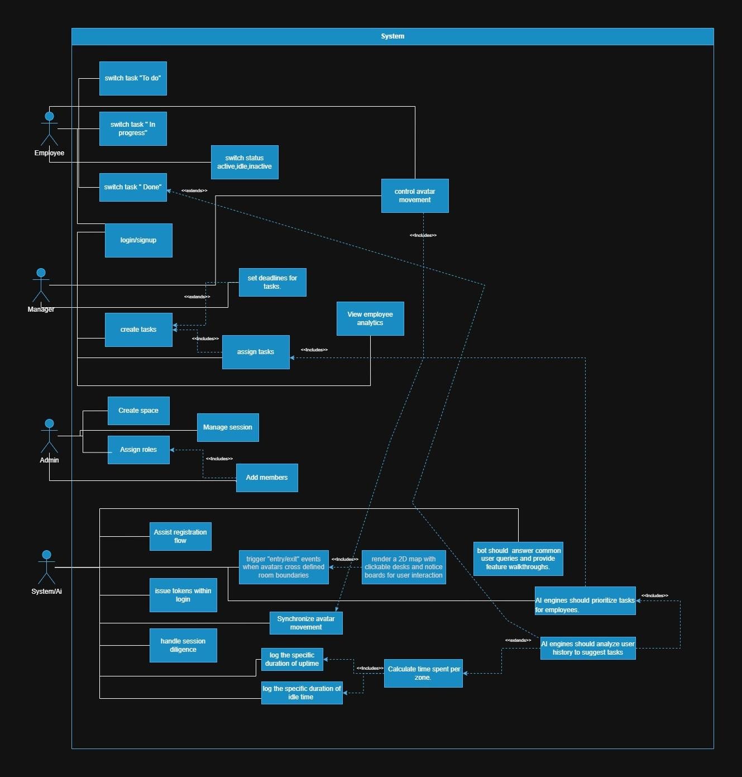

Figure 1: sample use case diagram with explanation

Extended use cases
3.5.1 Login
Use Case ID: | UC 01
Use Case Name: | Login
Created By: | Mian Muhammad Haris |  | Last Updated By: | Mian Muhammad Haris
Date Created: | 13 January 2026 |  | Last Revision Date: | 13 January 2026
Actors: |  | User (Employee, Manager)
Description: |  | Users access the platform via their credentials, using JWT tokens for secure authentication. After verification it takes the user to their dashboard where they have the ability to perform the functions according to their roles.
Trigger: |  | User initiates login on the platform
Preconditions: |  | Following is the precondition  - The platform is online.  - User has a registered account.
Post conditions: |  | Following are the postcondition  - After the authentication process, the user is directed to their dashboard with role based access and control..
Normal Flow: |  | The normal flow will be:  - The user enters the log in page.  - Put in their username or email and password.  - Click on the button titled Login.  - The credentials are authenticated in the system.  - Upon confirmation, one is logged into their dashboard.
Alternative Flows: |  | [Alternative Flow 1 – Invalid Credentials]  a. If the user enters invalid credentials:  - An error message comes up in the system.  - The user inputs valid logins again.  - At step 4 flow is restored.
Exceptions: |  | If too many failed attempts, the account is locked, and a message is displayed.
Includes: |  | UC 02: Signup
Frequency of Use: |  | 300 users per day
Special Requirements: |  | - Passwords must meet security standards.  - JWT tokens for safe and secure session management
Assumptions: |  | - Users remember their credentials.  - The system’s authentication services are operational.
Notes and Issues: |  | - The attempts to use the login facility should be rate limited to eliminate the possibility of a brute force attack.
3.5.2 Signup
Use Case ID: | UC 02
Use Case Name: | Signup
Created By: | Mian Muhammad Haris |  | Last Updated By: | Mian Muhammad Haris
Date Created: | 13 January 2026 |  | Last Revision Date: | 13 January 2026
Actors: |  | New User
Description: |  | New users register by entering their details and selecting a role Employee,Manager or Admin. The system creates an account and assigns permissions according to the selected role.
Trigger: |  | User clicks on Signup button
Preconditions: |  | Following is the precondition  1. The platform is accessible.  2. The user has a valid email address.
Post conditions: |  | Following are the postcondition  - The User account is created in the database.  - The user receives a confirmation email.  - User can proceed to login.
Normal Flow: |  | The normal flow will be:  - The user navigates to the signup page.  - The user selects roles (Employee,Manager or Admin).  - The user enters name, email, and password.  - The user accepts terms and conditions.  - Click on the button titled Sign Up.  6. The system validates input data.  7. The system creates the account.  8. A confirmation message is displayed.
Alternative Flows: |  | [Alternative Flow 1 – Email already exists]  a.If the email is already registered:  1. System displays error "Email already exists".  2. The user uses different email or proceeds to login.  3. At step 3 flow is restored.
Exceptions: |  | If email service is down user has to wait and try again
Includes: |  | UC 03: Avatar Customization
Frequency of Use: |  | 20 new users per day
Special Requirements: |  | - Email verification must be implemented.  - Password strength validation required.  - GDPR compliance for data collection.
Assumptions: |  | - Users provide valid information.  - Email service is operational.
Notes and Issues: |  | - Consider implementing CAPTCHA to prevent bot registrations.
3.5.3 Avatar Customization
Use Case ID: | UC 03
Use Case Name: | Avatar Customization
Created By: | Mian Muhammad Haris |  | Last Updated By: | Mian Muhammad Haris
Date Created: | 13 January 2026 |  | Last Revision Date: | 13 January 2026
Actors: |  | Employee,Manager,Admin
Description: |  | Users are assigned a unique avatar upon registration and can modify its visuals including color, dressing, and specials . Changes are displayed in real time through WebSockets for all active users.
Trigger: |  | Access avatar customization menu
Preconditions: |  | Following is the precondition  1. The user is logged into the platform.  2. The user has been assigned a default avatar.
Post conditions: |  | Following are the postcondition  - Avatar changes are saved to the database.  - Changes are implemented in real-time for all active users.  - The updated avatar is visible to all users in the virtual office.
Normal Flow: |  | The normal flow will be:  - The user clicks on the avatar and selects avatar settings from the drop down menu.  - The system displays a customization interface.  - The user selects appearance options ( color, dressing, and specials).  - User previews changes in real-time.  - User clicks Save.  - System updates avatar across all sessions.
Alternative Flows: |  | [Alternative Flow 1 – Page refresh]  a.If user refreshes the page  - Changes are discarded
Exceptions: |  | If WebSocket connection fails, changes are queued and applied when connection is restored.
Includes: |  | -
Frequency of Use: |  | 20 customizations per day
Special Requirements: |  | - Real-time synchronization via WebSockets.  - Avatar rendering must be optimized for performance.
Assumptions: |  | - WebSocket connection is stable.  - Avatar assets are preloaded.
Notes and Issues: |  | - Future versions may include premium customization options.
3.5.4 Manage Presence Status
Use Case ID: | UC 04
Use Case Name: | Manage Presence Status
Created By: | Mian Muhammad Haris |  | Last Updated By: | Mian Muhammad Haris
Date Created: | 13 January 2026 |  | Last Revision Date: | 13 January 2026
Actors: |  | Employee,Manager
Description: |  | The system automatically tracks and displays indicators for active, idle, or offline status.
Trigger: |  | The user logs in or the system detects inactivity.
Preconditions: |  | Following is the precondition  1. The user is logged into the platform.
Post conditions: |  | Following are the postcondition  - Presence status is updated and visible to all users.  - Status changes are logged for analytics.
Normal Flow: |  | The normal flow will be:  - The system detects keyboard/mouse activity.  - Status is set to "Active".  - After 5 minutes of inactivity, status changes to "Idle".  - When the user logs out, status changes to "Offline".  - All status changes are broadcast via WebSockets.
Alternative Flows: |  | [Alternative Flow 1 – Manual status update]  a.User clicks on status indicator:  1. System displays status options menu.  2. User selects custom status ("In Meeting", "Do Not Disturb").  3. System updates and broadcasts new status.
Exceptions: |  | If WebSocket connection fails, changes are queued and applied when connection is restored.
Includes: |  | -
Frequency of Use: |  | During active session continuous
Special Requirements: |  | - Inactivity detection algorithm.  - WebSocket support for real time updates.
Assumptions: |  | - The system can accurately detect user activity.  - Network connection is stable.
Notes and Issues: |  | -

3.5.5 Navigate virtual Office
Use Case ID: | UC 05
Use Case Name: | Navigate Virtual Office
Created By: | Mian Muhammad Haris |  | Last Updated By: | Mian Muhammad Haris
Date Created: | 13 January 2026 |  | Last Revision Date: | 13 January 2026
Actors: |  | Employee,Manager
Description: |  | Users move their avatars through a 2D rendered office layout using mouse clicks or keyboard arrow keys (WASD).
Trigger: |  | The user gives input via mouse or keyboard
Preconditions: |  | Following is the precondition  - The user is logged into the virtual office.  - 2D office layout is loaded.
Post conditions: |  | Following are the postcondition  - Avatar position is updated in the database.  - Movement is synchronized to all connected users in real-time.
Normal Flow: |  | The normal flow will be:  - The user clicks on a location or uses keyboard controls.  - Avatar moves toward the target location.  - System updates avatar coordinates.  - Position is broadcast via WebSockets.  - Other users see the avatar moving in real-time.
Alternative Flows: |  | [Alternative Flow 1 – Collision detection]  a.If avatar encounters an obstacle:  1. Movement stops at the collision boundary.  2. Users must choose an alternate path.
Exceptions: |  | If network latency is high, movement may appear delayed or jerky.
Includes: |  | UC 06: Enter/Exit Virtual Room
Frequency of Use: |  | During active session continuous
Special Requirements: |  | - Real-time movement synchronization via WebSockets.  - Smooth animation and collision detection.  - Optimized rendering for multiple avatars.
Assumptions: |  | - The client device has sufficient processing power.  - Network latency is acceptable (<100ms).
Notes and Issues: |  | - Consider implementing pathfinding algorithms for smoother navigation.

3.5.6 Enter/Exit Virtual Room
Use Case ID: | UC 06
Use Case Name: | Enter/Exit Virtual Room
Created By: | Mian Muhammad Haris |  | Last Updated By: | Mian Muhammad Haris
Date Created: | 13 January 2026 |  | Last Revision Date: | 13 January 2026
Actors: |  | Employee,Manager
Description: |  | The system automatically detects when an avatar crosses a room boundary.
Trigger: |  | Avatar crosses room boundaries.
Preconditions: |  | Following is the precondition  - The user is navigating the virtual office.  - Room boundaries are defined in the system.
Post conditions: |  | Following are the postcondition  - The user is connected to a room specific communication channel.  - Room entry/exit is logged for analytics.  - Other users in the room are notified.
Normal Flow: |  | The normal flow will be:  - Avatar approaches the room boundary.  - The system detects collisions with the room zone.  - Entry notification is displayed.  - Users are added to the room participant list.  - Room specific chat and audio channels are activated.  - When avatar exits, channels are disconnected.
Alternative Flows: |  | [Alternative Flow 1 – Private room access]  A. If room is private:  1. The system checks user permissions.  2. If unauthorized, entry is blocked and message is displayed.  3. If authorized, normal flow continues.
Exceptions: |  | If room capacity is exceeded, the user is notified and entry is prevented.
Includes: |  | UC 08: Room Presence Tracking  UC 18: Participate in Meeting Rooms
Frequency of Use: |  | 100 room transitions per day
Special Requirements: |  | - Accurate collision detection.  - Room based communication channels.  - Permission management system.
Assumptions: |  | - Room boundaries are properly configured.  - The system can handle multiple simultaneous room transitions.
Notes and Issues: |  | _

3.5.7 Enter/Exit Virtual Room
Use Case ID: | UC 07
Use Case Name: | Interact with Office Elements
Created By: | Mian Muhammad Haris |  | Last Updated By: | Mian Muhammad Haris
Date Created: | 13 January 2026 |  | Last Revision Date: | 13 January 2026
Actors: |  | Employee,Manager
Description: |  | Users click on interactive elements within the office layout.
Trigger: |  | The user clicks on an interactive office element.
Preconditions: |  | Following is the precondition  - The user is in the virtual office.  - Interactive elements are rendered and clickable.
Post conditions: |  | Following are the postcondition  - action is executed according to the clicked element.  - Interaction is logged for analytics.
Normal Flow: |  | The normal flow will be:  - The user hovers over an interactive element.  - Cursor changes to indicate interactivity.  - The user clicks on the element.  - The system triggers action accordingly.  - Modal or overlay displays relevant content.  - User closes the interaction.
Alternative Flows: |  | [Alternative Flow 1 – Multi user Interaction]  a.If element supports collaboration e.g., scrum board:  1. The system opens the scrum board.  2. Multiple users can access simultaneously.  3. Task assignments and updations are displayed in real time.
Exceptions: |  | If an element's associated service is unavailable, an error message is displayed.
Includes: |  | UC 11: View Scrum Board
Frequency of Use: |  | 150 interactions per day
Special Requirements: |  | - Clear visual feedback for interactive elements.  - Hover effects and cursor changes.  - Support for various element types.
Assumptions: |  | - Interactive elements are properly configured.  - Services are operational.
Notes and Issues: |  | _

3.5.8 Room Presence Tracking
Use Case ID: | UC 08
Use Case Name: | Room Presence Tracking
Created By: | Mian Muhammad Haris |  | Last Updated By: | Mian Muhammad Haris
Date Created: | 13 January 2026 |  | Last Revision Date: | 13 January 2026
Actors: |  | Admin,Manager
Description: |  | The platform automatically logs the duration of time an avatar spends in specific zones or rooms. This data is used for activity summaries and productivity analysis.
Trigger: |  | Avatar enters or exits a room.
Preconditions: |  | Following is the precondition  - The user is logged into the virtual office.  - The room tracking system is active.
Post conditions: |  | Following are the postcondition  - Entry and exit timestamps are recorded.  - Duration is calculated and stored.  - Data is available for reporting and analytics.
Normal Flow: |  | The normal flow will be:  - The system detects an avatar entering a room.  - Entry timestamp is recorded.  - User presence in the room is monitored.  - When the avatar exits, the exit timestamp is recorded.  - Duration is calculated by exit time - entry time.  - Data is stored in the database.  - Statistics are updated.
Alternative Flows: |  | [Alternative Flow 1 – Session Interruption ]  a.If user logs out while in a room:  1. Logout timestamp is used as exit time.  2. Duration is calculated accordingly.
Exceptions: |  | If a system crash occurs, the last known position is used to estimate duration.
Includes: |  | UC 22: View Daily Activity Summaries  UC 24: Monitor Uptime & Idle Time
Frequency of Use: |  | During active session continuous
Special Requirements: |  | - Accurate timestamping.  - Efficient database storage for tracking data.
Assumptions: |  | - The system clock is synchronized.  - Databases can handle high frequency writes.
Notes and Issues: |  | - Users should be informed about tracking for transparency.
3.5.9 Create task
Use Case ID: | UC 09
Use Case Name: | Create task
Created By: | Mian Muhammad Haris |  | Last Updated By: | Mian Muhammad Haris
Date Created: | 13 January 2026 |  | Last Revision Date: | 13 January 2026
Actors: |  | Manager
Description: |  | The manager creates a new task with a title, description, deadline, and priority level. The task is added to the Scrum board in the "To Do" column.
Trigger: |  | The manager clicks the "Create Task" button.
Preconditions: |  | Following is the precondition  - Manager is logged into the platform.  - The manager has access to task management features.
Post conditions: |  | Following are the postcondition  - The task is created in the database.  - Task appears on the Scrum board.  - The task is ready to be assigned to a user.
Normal Flow: |  | The normal flow will be:  - Manager navigates to the Scrum board.  - The manager clicks the "Create Task" button.  - Task creation form is displayed.  - The manager enters task title, description, deadline, and priority.  - The manager clicks "Save".  - The system validates input data.  - Task is created and added to the "To Do" column.  - Success message is displayed.
Alternative Flows: |  | [Alternative Flow 1 – Missing required fields]  a.If required fields are empty:  - Error messages are displayed.  - Manager fills in missing information.
Exceptions: |  | If the database connection fails, the task is queued locally and created when connection is restored.
Includes: |  | UC 10: Assign Task
Frequency of Use: |  | 30 tasks created per day
Special Requirements: |  | - Form validation for required fields.  - Date picker for deadline selection.  - Priority levels (High, Medium, Low or 1 to 5).
Assumptions: |  | - The manager has necessary information to create meaningful tasks.  - The database is operational.
Notes and Issues: |  | - Consider adding task templates for common task types.

3.5.10 Assign task
Use Case ID: | UC 10
Use Case Name: | Assign task
Created By: | Mian Muhammad Haris |  | Last Updated By: | Mian Muhammad Haris
Date Created: | 13 January 2026 |  | Last Revision Date: | 13 January 2026
Actors: |  | Manager
Description: |  | Manager allocates a specific task to an Employee.The assigned employee receives a notification.
Trigger: |  | The manager selects an employee for a task.
Preconditions: |  | Following is the precondition  - A task has been created.  - Users are registered in the system.  - Manager has assignment permissions.
Post conditions: |  | Following are the postcondition  - The task is assigned to a selected user.  - The user receives notification.  - Task appears in task list.  - Assignment is logged in the database.
Normal Flow: |  | The normal flow will be:  - Manager opens task details.  - The manager clicks the "Assign" button.  - The system displays a list of available employees.  - The manager selects an user.  - The manager optionally adds assignment notes.  - Manager clicks "Confirm".  - System updates task assignee.  - Notification is sent to the user.  - Success message is displayed.
Alternative Flows: |  | [Alternative Flow 1 – Reassign task]  a. If task is already assigned:  - The manager can reassign different users.  - Both old and new assignees are notified.
Exceptions: |  | If the selected employee is unavailable the system displays a warning.
Includes: |  | UC 14: Monitor Task Progress
Frequency of Use: |  | 30 assignments per day
Special Requirements: |  | - Real-time notification system.  - Employee availability status.  - Assignment history tracking.
Assumptions: |  | -
Notes and Issues: |  | - Consider workload balancing algorithms to suggest optimal assignees.

3.5.11 View scrum board
Use Case ID: | UC 11
Use Case Name: | View Scrum Board
Created By: | Mian Muhammad Haris |  | Last Updated By: | Mian Muhammad Haris
Date Created: | 13 January 2026 |  | Last Revision Date: | 13 January 2026
Actors: |  | Employee, Manager
Description: |  | Users access a Kanban style board displaying all team tasks organized in three columns: "To Do", "In Progress", and "Done". Tasks are shown as cards with summary information.
Trigger: |  | The user clicks on the Scrum board icon or menu item.
Preconditions: |  | Following is the precondition  - The user is logged into the platform.  - Tasks exist in the system.
Post conditions: |  | Following are the postcondition  - Scrum board is displayed with current task statuses.  - Users can view and interact with tasks.
Normal Flow: |  | The normal flow will be:  - The user navigates to the task management section.  - The user clicks "Scrum Board".  - The system retrieves all tasks from the database.  - Tasks are organized by status column.  - Each task card displays title, assignee, and deadline.  - The board is rendered with drag-and-drop functionality enabled.
Alternative Flows: |  | [Alternative Flow 1 – Filter task]  a User applies filters by assignee, priority, or deadline:  - Only matching tasks are displayed.  - User can clear filters to see all tasks.
Exceptions: |  | If no tasks exist, an empty state message is displayed with the option to create the first task..
Includes: |  | UC 12: Update Task Status  UC 13: View Task Details
Frequency of Use: |  | 200 board views per day
Special Requirements: |  | - Responsive layout for various screen sizes.  - Real-time updates via WebSockets.  - Drag-and-drop library integration.
Assumptions: |  | - Users have proper permissions to view tasks.  - System can handle concurrent board access.-
Notes and Issues: |  | - Consider workload balancing algorithms to suggest optimal assignees.

3.5.12 Update task status
Use Case ID: | UC 12
Use Case Name: | Update task status
Created By: | Mian Muhammad Haris |  | Last Updated By: | Mian Muhammad Haris
Date Created: | 13 January 2026 |  | Last Revision Date: | 13 January 2026
Actors: |  | Employee
Description: |  | Employee uses drag-and-drop functionality to move task cards between workflow columns "To Do" to "In Progress" to "Done", updating the task status automatically.
Trigger: |  | Employee drags a task card to a different column.
Preconditions: |  | Following is the precondition  - The employee is viewing the Scrum board .  - A task is assigned to the employee.  - Employees have update permissions.
Post conditions: |  | Following are the postcondition  - Task status is updated in the database.  - Status change is broadcast to all users.  - Manager receives notification of status change.  - Task history is updated.
Normal Flow: |  | The normal flow will be:  - Employee clicks and holds on a task card.  - The employee drags the card to the target column.  - Visual feedback indicates a valid drop zone.  - The employee releases the card.  - The system validates the status transition.  - Task status is updated in the database.  - Card animates to its new position.  - All connected users see the update in real-time.  - Manager receives notification.
Alternative Flows: |  | [Alternative Flow 1 – Invalid Transition]  a If transition is not allowed e.g., "Done" to "To Do":  - Card returns to original position.  - Warning message is displayed.  - User must use proper workflow.
Exceptions: |  | If a network connection fails, update is queued and applied when connection is restored.
Includes: |  | UC 14: Monitor Task Progress
Frequency of Use: |  | 80 status updates per day
Special Requirements: |  | - Smooth drag and drop animation.  - Real-time synchronization via WebSockets.  - Status transition validation rules.
Assumptions: |  | - Users understand the workflow sequence.  - Network latency is acceptable.
Notes and Issues: |  | - Consider adding confirmation dialog for moving to "Done" status.

3.5.13 View Task Details
Use Case ID: | UC 13
Use Case Name: | View Task Details
Created By: | Mian Muhammad Haris |  | Last Updated By: | Mian Muhammad Haris
Date Created: | 13 January 2026 |  | Last Revision Date: | 13 January 2026
Actors: |  | Employee, Manager
Description: |  | When users hover their cursor over a task card on the Scrum board, a popup displays detailed task information including full description, assignee, deadline, priority, and progress.
Trigger: |  | The user hovers the cursor over a task card.
Preconditions: |  | Following is the precondition  - The user is viewing the Scrum board.  - Task cards are displayed.
Post conditions: |  | Following are the postcondition  - Task details are displayed temporarily.  - Details disappear when the cursor moves away.
Normal Flow: |  | The normal flow will be:  - The user positions the cursor over a task card.  - After 0.5 second delay, tooltip appears.  - The user reads the information.  - The user moves the cursor away.  - Tooltip fades out and disappears.
Alternative Flows: |  | [Alternative Flow 1 –Click for full details]  a User clicks on task card:  - Full details modal opens.  - Users can edit tasks if authorized.  - User closes modal.
Exceptions: |  | If task data is incomplete, available information is shown with placeholders for missing data.
Includes: |  | -
Frequency of Use: |  | 300 hover interactions per day
Special Requirements: |  | - Responsive popup positioning.  - Delay before showing tooltip to avoid cluttering the interface.  - Proper z-index layering.
Assumptions: |  | - Task data is available in the browser.  - Popup doesn't obstruct other interface elements.
Notes and Issues: |  | - Consider adding quick action buttons in tooltip "Start Task", "Mark Complete".

3.5.14 Monitor Task Progress
Use Case ID: | UC 14
Use Case Name: | Monitor Task Progress
Created By: | Mian Muhammad Haris |  | Last Updated By: | Mian Muhammad Haris
Date Created: | 13 January 2026 |  | Last Revision Date: | 13 January 2026
Actors: |  | Manager
Description: |  | The manager views real time completion statistics and status updates for all team tasks. Dashboard displays metrics like tasks completed, in progress, overdue, and employee statistics.
Trigger: |  | Manager accesses task monitoring dashboard.
Preconditions: |  | Following is the precondition  - Manager is logged into the platform.  - Tasks exist in the system.  - The manager has monitoring permissions.
Post conditions: |  | Following are the postcondition  - The manager has a current overview of team task status.  - Insights can inform task assignment decisions.
Normal Flow: |  | The normal flow will be:  - Manager navigates to the task monitoring section.  - The system retrieves all task data.  - Dashboard display  - Manager reviews statistics.  - Managers can drill down into specific metrics.  - The manager can export reports.
Alternative Flows: |  | [Alternative Flow 1 – Filter By Data Range]  a Manager selects custom date range:  - Statistics are recalculated for selected periods.  - Visualizations update accordingly.
Exceptions: |  | If no tasks exist for a selected period, an empty state is displayed.
Includes: |  | UC 23: Track Productivity Metrics
Frequency of Use: |  | 50 monitoring sessions per day
Special Requirements: |  | - Real-time data updates.  - Interactive charts and graphs.  - Export functionality (PDF, Excel,Word,etcl).
Assumptions: |  | - Task data is accurate and up-to-date.  - The system can perform queries efficiently.
Notes and Issues: |  | - Consider adding predictive analytics for task completion estimates.

3.5.15 Text Chat
Use Case ID: | UC 15
Use Case Name: | Text chat
Created By: | Mian Muhammad Haris |  | Last Updated By: | Mian Muhammad Haris
Date Created: | 13 January 2026 |  | Last Revision Date: | 13 January 2026
Actors: |  | Employee,Manager
Description: |  | Users exchange text messages in real time through direct messages or group channels. Messages support text formatting, emojis, and file attachments.
Trigger: |  | The user opens the chat interface and sends a message.
Preconditions: |  | Following is the precondition  - The user is logged into the platform.  - Chat functionality is enabled.
Post conditions: |  | Following are the postcondition  - Message is delivered to recipient.  - Messages are stored in chat history.  - Recipient receives notification.
Normal Flow: |  | The normal flow will be:User opens chat panel.  - User selects recipient or group channel.  - User types message in input field.  - The user optionally formats text or adds emoji.  - The user presses Enter or clicks Send.  - Message is transmitted via WebSocket.  - The Message appears in the sender's chat window.  - Message is delivered to recipient(s).  - Recipient sees notification.  - Message is stored in the database.
Alternative Flows: |  | [Alternative Flow 1 – Send File Attachment]  a User clicks attachment icon:  - File picker dialog opens.  - User selects file (max 10MB).  - The file is uploaded to the server.  - Message with file link is sent.
Exceptions: |  | If the recipient is offline, a message is queued and delivered when they come online.
Includes: |  | -
Frequency of Use: |  | 500 messages per day
Special Requirements: |  | - WebSocket for real-time messaging.  - Message persistence in database.  - File upload support.  - Emoji picker integration.
Assumptions: |  | - Network connection is stable.  - Chat server is operational.
Notes and Issues: |  | - Consider end-to-end encryption for private messages.

3.5.16 Voice/Video call
Use Case ID: | UC 16
Use Case Name: | Voice/Video call
Created By: | Mian Muhammad Haris |  | Last Updated By: | Mian Muhammad Haris
Date Created: | 13 January 2026 |  | Last Revision Date: | 13 January 2026
Actors: |  | Employee,Manager
Description: |  | Users initiate audio or video sessions within meeting rooms using WebRTC technology. Supports multiple participants with high quality audio and video streams.
Trigger: |  | The user initiates a call within a meeting room.
Preconditions: |  | Following is the precondition  - The user is in a virtual meeting room.  - The user has granted microphone/camera permissions.  - WebRTC is supported by the browser.
Post conditions: |  | Following are the postcondition  - A call session is established.  - Audio/video streams are connected.  - Call duration is logged.
Normal Flow: |  | The normal flow will be:User opens chat panel.  - The user enters a meeting room.  - The user clicks the "Start Call" button.  - System requests microphone/camera permissions.  - User grants permissions.  - The system initializes the WebRTC connection.  - Other users in the room receive call notification.  - Participants join the call.  - Audio/video streams are transmitted.  - Call quality indicators are displayed.  - Users can toggle camera/microphone on/off.
Alternative Flows: |  | [Alternative Flow 1 – Join Ongoing call]  a If the call is already in progress:  - The user sees the "Join Call" button.  - Users click to join an existing session.  - User is added to the call.
Exceptions: |  | If permissions are denied, the user is notified and calls cannot proceed.
Includes: |  | UC 17: Initiate Screen Sharing  UC 18: Participate in Meeting Rooms
Frequency of Use: |  | 40 calls per day
Special Requirements: |  | - WebRTC support for peer to peer communication.  - TURN/STUN servers for NAT traversal.  - Bandwidth optimization.  - Echo cancellation and noise suppression.
Assumptions: |  | - Users have adequate internet bandwidth.  - Browser supports WebRTC.
Notes and Issues: |  | -

3.5.17 initiate Screen Sharing
Use Case ID: | UC 17
Use Case Name: | Initiate Screen Sharing
Created By: | Mian Muhammad Haris |  | Last Updated By: | Mian Muhammad Haris
Date Created: | 13 January 2026 |  | Last Revision Date: | 13 January 2026
Actors: |  | Employee,Manager
Description: |  | Users share their physical desktop screens with others in a meeting room for collaborative reviews, presentations, or troubleshooting. Uses screen capture API.
Trigger: |  | The user clicks the "Share Screen" button during a call.
Preconditions: |  | Following is the precondition  - The user is in an active voice/video call.  - Browser supports screen capture API.
Post conditions: |  | Following are the postcondition  - The user's screen is visible to all call participants.  - Screen sharing session is logged.
Normal Flow: |  | The normal flow will be:User opens chat panel.  - The user is in an active call.  - The user clicks the "Share Screen" button.  - System requests screen capture permission.  - Screen selection dialog appears.  - The user selects screen, window, or tab to share.  - User confirms selection.  - Screen feed is broadcast to all participants.  - Other users see the shared screen.  - Users can stop sharing at any time.
Alternative Flows: |  | [Alternative Flow 1 – Share Specific Window]  a User selects a specific application window:  - Only that window is shared.  - Privacy is maintained for other content.
Exceptions: |  | If permission is denied, screen sharing fails and the user is notified.
Includes: |  | -
Frequency of Use: |  | 20 screen shares per day
Special Requirements: |  | - Screen capture API support.  - High-quality video encoding.  - Low latency streaming.  - Permission management.
Assumptions: |  | - Browser supports getDisplayMedia API.  - Network bandwidth can handle video streams.
Notes and Issues: |  | -

3.5.18 Participate in Meeting Rooms
Use Case ID: | UC 18
Use Case Name: | Text chat
Created By: | Mian Muhammad Haris |  | Last Updated By: | Mian Muhammad Haris
Date Created: | 13 January 2026 |  | Last Revision Date: | 13 January 2026
Actors: |  | Employee,Manager
Description: |  | Multiple avatars gather in a designated virtual meeting room for synchronized discussion, collaboration, and decision making. The room provides integrated communication tools.
Trigger: |  | The user's avatar enters a meeting room zone.
Preconditions: |  | Following is the precondition  - The user is logged into the virtual office.  - The meeting room is defined in the system.  - The user has permission to access the room.
Post conditions: |  | Following are the postcondition  - The user is connected to meeting room participants.  - Room specific communication channels are active.  - Participation is logged for analytics.
Normal Flow: |  | The normal flow will be:User opens chat panel.  - The user navigates to the meeting room entrance.  - System detects room entry (UC 06).  - The meeting room interface is activated.  - The user sees a list of current participants.  - Users can access chat, voice, video features.  - The user participates in discussion.  - Users can share screens or view shared content.  - When done, the user exits the room.  - Communication channels are disconnected.
Alternative Flows: |  | [Alternative Flow 1 – Scheduled Meeting ]  a User joins scheduled meeting:  - The user receives a meeting notification.  - The user clicks the "Join Meeting" link.  - Avatar is teleported to a meeting room.
Exceptions: |  | If the meeting room is full, the user is added to the waiting list and notified when space is available.
Includes: |  | UC 15: Text Chat  UC 16: Voice/Video Calling  UC 17: Initiate Screen Sharing
Frequency of Use: |  | 30 meeting room sessions per day
Special Requirements: |  | - Spatial audio for proximity-based communication.  - Meeting room capacity limits.  - Whiteboard integration.
Assumptions: |  | - Meeting rooms are properly configured.  - Multiple users can join simultaneously.
Notes and Issues: |  | -

3.5.19 AI Task Recommendation
Use Case ID: | UC 19
Use Case Name: | AI Task Recommendation
Created By: | Mian Muhammad Haris |  | Last Updated By: | Mian Muhammad Haris
Date Created: | 13 January 2026 |  | Last Revision Date: | 13 January 2026
Actors: |  | Employee,Manager
Description: |  | AI engine analyzes employee behavior, skills, task history, and current workload to suggest relevant tasks that match their capabilities and availability.
Trigger: |  | The system periodically analyzes task pools and employee profiles.
Preconditions: |  | Following is the precondition  - Employees are logged into the platform.  - Unassigned tasks exist in the system.  - The AI recommendation engine is active.  - Sufficient historical data exists for analysis.
Post conditions: |  | Following are the postcondition  - Recommended tasks are displayed to employees.  - Employees can accept or decline recommendations.  - Recommendations are logged for ML model improvement.
Normal Flow: |  | The normal flow will be:User opens chat panel.  - The AI system analyzes employee profile and history.  - The system evaluates unassigned tasks.  - The system generates a recommendation list.  - Employees receive notification of recommendations.  - Employee views recommended tasks.  - Employees can accept tasks (auto-assigns).  - Employees can decline with optional feedback.
Alternative Flows: |  | [Alternative Flow 1 – No Suitable Task ]  a If no tasks match employee profile:  - The system notifies employees no recommendations available.  - Employee can browse all tasks manually.
Exceptions: |  | If AI service is unavailable, manual task assignment is used.
Includes: |  | UC 10: Assign Task
Frequency of Use: |  | Continuous background process
Special Requirements: |  | - Machine learning model for task matching.  - Employee skill profile database.  - Real-time recommendation engine.  - Feedback loop for model improvement.
Assumptions: |  | - AI models are trained with sufficient data.  - Employee profiles are accurate and updated.
Notes and Issues: |  | - Consider adding an explanation feature for why tasks are recommended.

3.5.20 AI Task Recommendation
Use Case ID: | UC 20
Use Case Name: | Smart Task Prioritization
Created By: | Mian Muhammad Haris |  | Last Updated By: | Mian Muhammad Haris
Date Created: | 13 January 2026 |  | Last Revision Date: | 13 January 2026
Actors: |  | Employee,Manager
Description: |  | AI engine analyzes employee behavior, skills, task history, and current workload to suggest relevant tasks that match their capabilities and availability.
Trigger: |  | The manager requests task prioritization or the system performs automatic analysis.
Preconditions: |  | Following is the precondition  - Multiple tasks exist in the system.  - Tasks have assigned deadlines and priorities.  - The AI prioritization engine is operational.
Post conditions: |  | Following are the postcondition  - Tasks are reordered based on AI suggestions.  - Manager receives prioritization report.  - The team is notified of priority changes.
Normal Flow: |  | The normal flow will be:User opens chat panel.  - Manager opens task prioritization dashboard.  - The manager clicks the "AI Prioritize" button.  - The system analyzes all active tasks.  - The system generates prioritized task lists.  - Manager reviews AI suggestions.  - Managers can accept, modify, or reject suggestions.  - If accepted, task priorities are updated.  - Team members receive updated priorities.
Alternative Flows: |  | [Alternative Flow 1 – Automatic Prioritization ]  a System automatically prioritizes daily:  - AI runs scheduled analysis.  - Suggestions are sent to the manager for approval.  - Manager reviews via notification.
Exceptions: |  | If AI cannot determine clear priorities, manual prioritization is suggested.
Includes: |  | UC 14: Monitor Task Progress
Frequency of Use: |  | 5 to 10 prioritization sessions per day
Special Requirements: |  | - Advanced AI algorithm for priority calculation.  - Task dependency tracking.  - Impact assessment metrics.  - Conflict resolution logic.
Assumptions: |  | - Task data is complete and accurate.  - Dependencies are properly defined.
Notes and Issues: |  | - Consider adding an "urgent override" feature for critical tasks.

3.5.21 AI Chat Assistance
Use Case ID: | UC 21
Use Case Name: | Ai Chat Assistance
Created By: | Mian Muhammad Haris |  | Last Updated By: | Mian Muhammad Haris
Date Created: | 13 January 2026 |  | Last Revision Date: | 13 January 2026
Actors: |  | Employee,Manager
Description: |  | In-app AI-powered support bot answers common queries, guides users through platform features, and provides contextual help based on user actions and needs.
Trigger: |  | The manager requests task prioritization or the system performs automatic analysis.
Preconditions: |  | Following is the precondition  - The user is logged into the platform.  - AI chatbot service is operational.
Post conditions: |  | Following are the postcondition  - The user receives a relevant answer or guidance.  - Conversation is logged for improvement.  - Unresolved queries are escalated to human support.
Normal Flow: |  | The normal flow will be:User opens chat panel.  - The user clicks the AI assistant icon.  - Chat interface opens.  - User types question or selects from common topics.  - AI bot processes natural language queries.  - Both search for a knowledge base.  - Bot generates contextual response.  - Response is displayed with helpful links/resources.  - Users can ask follow-up questions.  - User rates response quality (optional).
Alternative Flows: |  | [Alternative Flow 1 – Contextual Help ]  aSystem detects user struggling with feature:  - AI assistants proactively offer help.  - Bot suggests relevant tutorials.  - User can accept or dismiss assistance.  [Alternative Flow 2 – Escalate to Human Support ]  b. If bot cannot answer query:  - Both offer to create support tickets.  - User confirms escalation.  - Ticket is created with conversation context.
Exceptions: |  | If AI service is down, the user is directed to help documentation or support email.
Includes: |  | -
Frequency of Use: |  | 100 chat sessions per day
Special Requirements: |  | - Natural language processing capability.  - Knowledge base integration.  - Multi-language support.  - Learning from user interactions.
Assumptions: |  | - AI models are trained on platform documentation.  - Both can handle common queries effectively.
Notes and Issues: |  | - Consider adding voice input for accessibility.

3.5.22 View Daily Activity Summaries
Use Case ID: | UC 22
Use Case Name: | View Daily Activity Summaries
Created By: | Mian Muhammad Haris |  | Last Updated By: | Mian Muhammad Haris
Date Created: | 13 January 2026 |  | Last Revision Date: | 13 January 2026
Actors: |  | Employee,Manager
Description: |  | Users access summaries of their daily completed tasks, time spent in various rooms, interactions, and milestones achieved. Provides personal productivity insights.
Trigger: |  | The user navigates to the activity summary section or receives daily summary notification.
Preconditions: |  | Following is the precondition  - User is logged into the platform.  - Activity data has been collected during the day.
Post conditions: |  | Following are the postcondition  - User views comprehensive daily activity report.  - User gains insights into their productivity patterns.
Normal Flow: |  | The normal flow will be:User opens chat panel.  - The user clicks on the "Daily Summary" menu item.  - The system retrieves the user's activity data for the day.  - Visual charts show activity distribution.  - Users can compare with previous days.  - Users can export summary as PDF.
Alternative Flows: |  | [Alternative Flow 1 – View Historical Summaries ]  aUser selects different date:  - The system loads data for selected dates.  - Summary is displayed accordingly.  [Alternative Flow 2 – Automated Daily Email ]  b. At end of workday:  - The system generates summary automatically.  - Summary is emailed to the user.  - User can click link to view detailed report.
Exceptions: |  | If no activity data exists for the selected date, an empty state is displayed.
Includes: |  | UC 08: Room Presence Tracking  UC 24: Monitor Uptime & Idle Time
Frequency of Use: |  | 300 summary views per day
Special Requirements: |  | - Data visualization libraries.  - PDF export functionality.  - Scheduled email generation.  - Historical data retention.
Assumptions: |  | - Activity tracking has been active throughout the day.  - Data is accurately recorded.
Notes and Issues: |  | -

3.5.23 Track Productivity Metrics
Use Case ID: | UC 23
Use Case Name: | Track Productivity metrics
Created By: | Mian Muhammad Haris |  | Last Updated By: | Mian Muhammad Haris
Date Created: | 13 January 2026 |  | Last Revision Date: | 13 January 2026
Actors: |  | Manager
Description: |  | The manager generates comprehensive reports on team productivity metrics including task completion rates, average task duration, employee performance, and bottleneck identification.
Trigger: |  | Manager accesses productivity analytics dashboard.
Preconditions: |  | Following is the precondition  - Manager is logged into the platform.  - Manager has analytics access permissions.  - Sufficient historical data exists for analysis.
Post conditions: |  | Following are the postcondition  - The manager has detailed productivity insights.  - Reports can be exported for presentations.  - Data informs management decisions.
Normal Flow: |  | The normal flow will be:User opens chat panel.  - The manager navigates to the analytics section.  - The manager selects the reporting period (day/week/month).  - The system aggregates productivity data.  - Dashboard displays  - Manager explores interactive charts.  - Managers can filter by employee, project, or date range.  - Manager exports reports (PDF, Excel, CSV).
Alternative Flows: |  | [Alternative Flow 1 – Compare Time Periods ]  aManager selects comparison mode:  - The system shows side-by-side period comparison.  - Trends and changes are highlighted..
Exceptions: |  | If insufficient data exists for the selected period, a warning message is displayed.
Includes: |  | UC 14: Monitor Task Progress  UC 24: Monitor Uptime & Idle Time
Frequency of Use: |  | 20 report generations per day
Special Requirements: |  | - Advanced data analytics engine.  - Interactive visualization tools.  - Multiple export formats.  - Scheduled report generation.
Assumptions: |  | - All activity data is accurately tracked.  - The system can handle complex aggregation queries.
Notes and Issues: |  | -

3.5.24 Monitor Uptime and Idle time
Use Case ID: | UC 24
Use Case Name: | Monitor Uptime and idle time
Created By: | Mian Muhammad Haris |  | Last Updated By: | Mian Muhammad Haris
Date Created: | 13 January 2026 |  | Last Revision Date: | 13 January 2026
Actors: |  | Manager
Description: |  | System logs and displays detailed breakdowns of user active work time versus inactive/idle periods. Helps managers understand engagement levels and identify availability patterns.
Trigger: |  | Manager accesses uptime monitoring dashboard.
Preconditions: |  | Following is the precondition  - The manager has monitoring permissions.  - The activity tracking system is operational.  - Employees are logged into the platform.
Post conditions: |  | Following are the postconditions  - Manager views comprehensive uptime/idle statistics.  - Patterns are identified for team management.
Normal Flow: |  | The normal flow will be:User opens chat panel.  - Manager opens uptime monitoring dashboard.  - The system displays real-time status of all employees.  - Dashboard shows:  - The manager can select specific employees for details.  - Detailed view shows activity breakdown by hour.  - Managers can export data for specific date ranges.
Alternative Flows: |  | [Alternative Flow 1 – Set Activity Alerts ]  aManager configures alert thresholds:  - Manager sets minimum expected uptime.  - System alerts if an employee falls below threshold.  - Notifications are sent to manager.
Exceptions: |  | If tracking data is incomplete due to system issues, gaps are indicated in the timeline.
Includes: |  | UC 04: Manage Presence Status  UC 08: Room Presence Tracking
Frequency of Use: |  | Continuous monitoring
Special Requirements: |  | - Real-time activity tracking.  - Accurate idle detection algorithm.  - Privacy-compliant monitoring.  - Alert notification system.
Assumptions: |  | - Activity detection is accurate.  - Employees are aware of monitoring.
Notes and Issues: |  | -

3.5.25 Role Based Access Control
Use Case ID: | UC 25
Use Case Name: | Role Based Access Control
Created By: | Mian Muhammad Haris |  | Last Updated By: | Mian Muhammad Haris
Date Created: | 13 January 2026 |  | Last Revision Date: | 13 January 2026
Actors: |  | Admin
Description: |  | Administrators manage user permissions and access levels to ensure that Managers can oversee tasks and analytics while Employees can only view/update their own assigned work.
Trigger: |  | Admin accesses user management or role configuration panel.
Preconditions: |  | Following is the precondition  - Admin is logged into the platform.  - Admin has full system permissions.  - User accounts exist in the system.
Post conditions: |  | Following are the postconditions  - User roles and permissions are updated.  - Access controls are enforced across the platform.  - Changes are logged in the audit trail.
Normal Flow: |  | The normal flow will be:User opens chat panel.  - Admin navigates to the user management section.  - Admin selects users to modify.  - The system displays current role and permissions.  - Admin can customize specific permissions within the role.  - Admin clicks "Save Changes".  - System validates permission configuration.  - Changes are applied immediately.  - The user receives notification of access changes.  - The system logs the modification in audit trail.
Alternative Flows: |  | [Alternative Flow 1 – Bulk Role Assignment ]  aAdmin selects multiple users:  - Admin applies to all selected users.  - The system confirms bulk operation.  - All users are updated simultaneously.  [Alternative Flow 2 – Create Custom Role ]  b. Admin creates a new custom role:  - Admin specifies role name and description.  - Admin selects permission set.  - Role is saved for future assignments.
Exceptions: |  | If attempting to remove all admins, the system prevents action and displays warning.
Includes: |  | -
Frequency of Use: |  | 10 role modifications per week
Special Requirements: |  | - Hierarchical permission system.  - Audit logging for all changes.  - Prevent accidental lockout scenarios.  - Real-time permission enforcement.
Assumptions: |  | - Clear role hierarchy is defined.  - Permission changes take effect immediately.
Notes and Issues: |  | - Consider implementing approval workflow for sensitive permission changes.  - Add ability to temporarily elevate permissions for specific tasks.

User interfaces (mock screens)
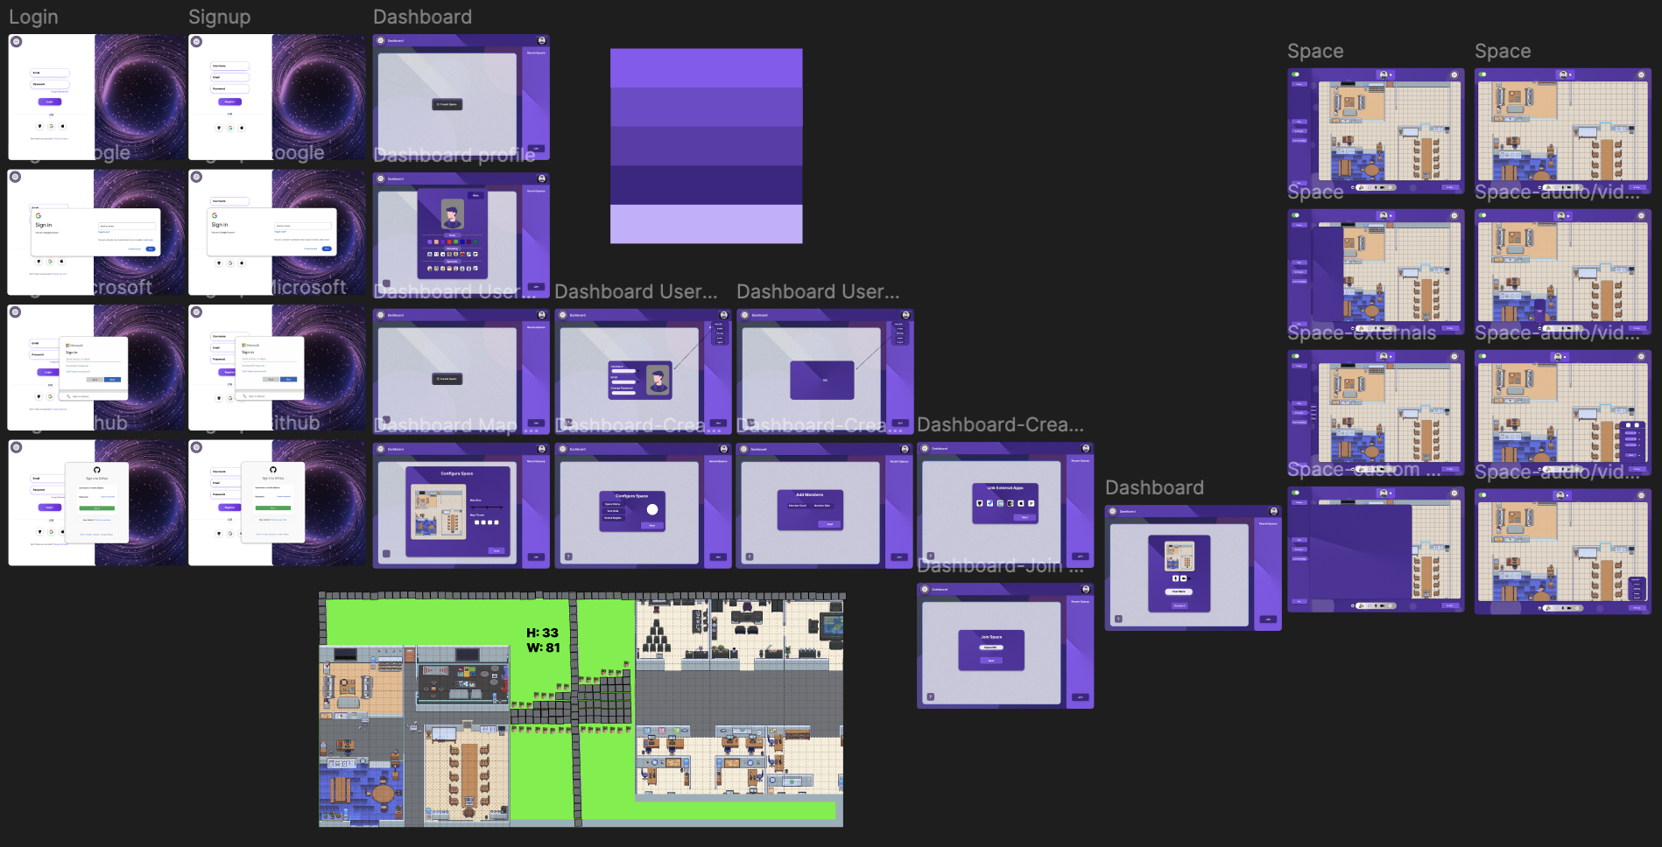
Prototype1: (P1) register a new member

Data flow diagram (optional)

Data Flow Diagram Level 0
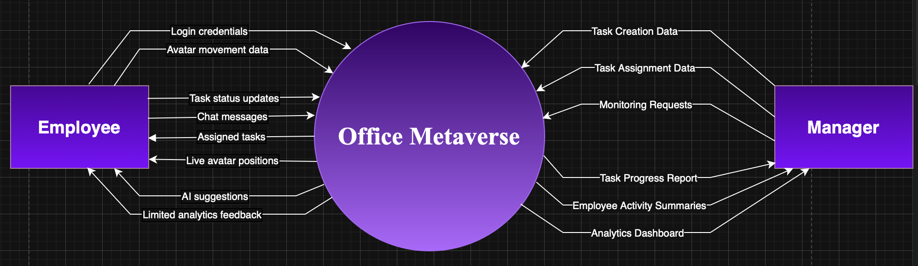
Figure 4.1: Data Flow Diagram (DFD) - 0

Data Flow Diagram Level 1
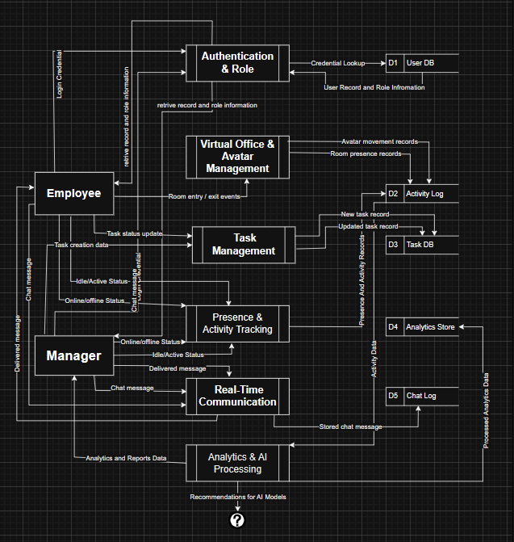

Data Flow Diagram Level 2
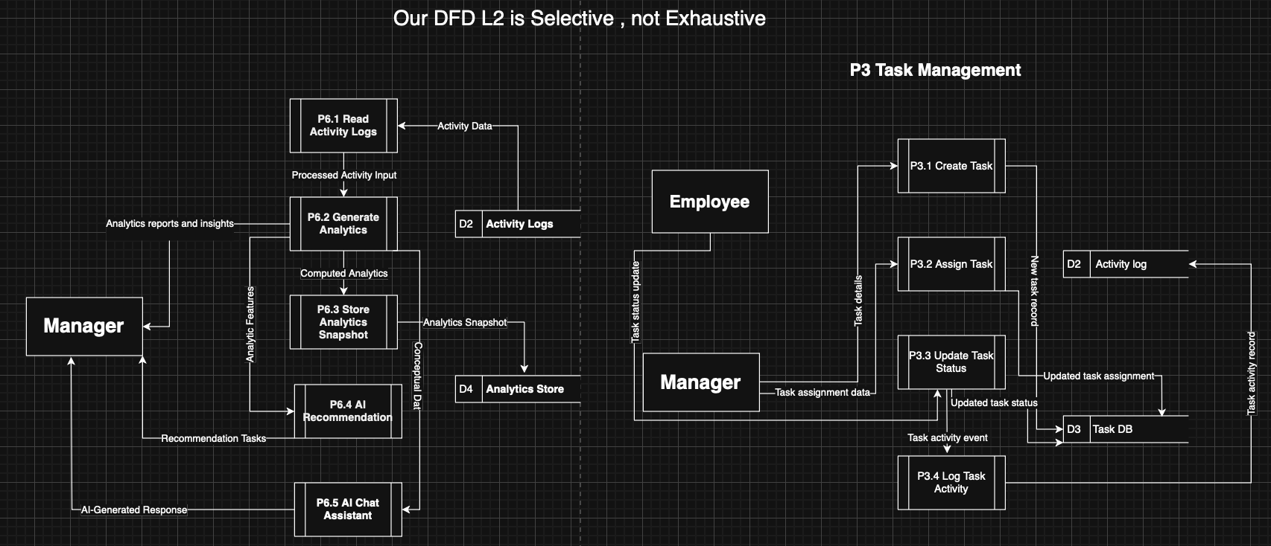

Figure 4.3: Data Flow Diagram (DFD) - 2

System Design
The system design of OM shows an overall plan of the structure and centralization of all significant parts of the software and their mutual interactions: user interface, server, database, and other additional services. The following diagram presents how a Client Server Application, Web Server, Application Server, Database, External Service will work together in order to provide the end-users with an easy and efficient environment. It emphasizes the fact that the proposed system minimizes many steps to handle service requests and tasks, to communicate or to update status in order to have effective and efficient service delivery in the service process.

System Architecture Diagram
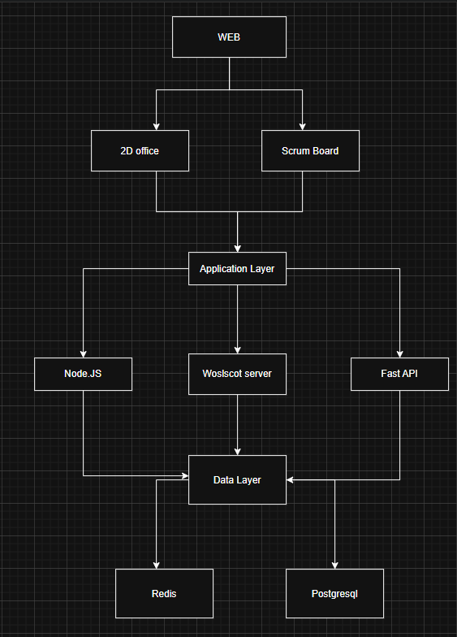

Class Diagram

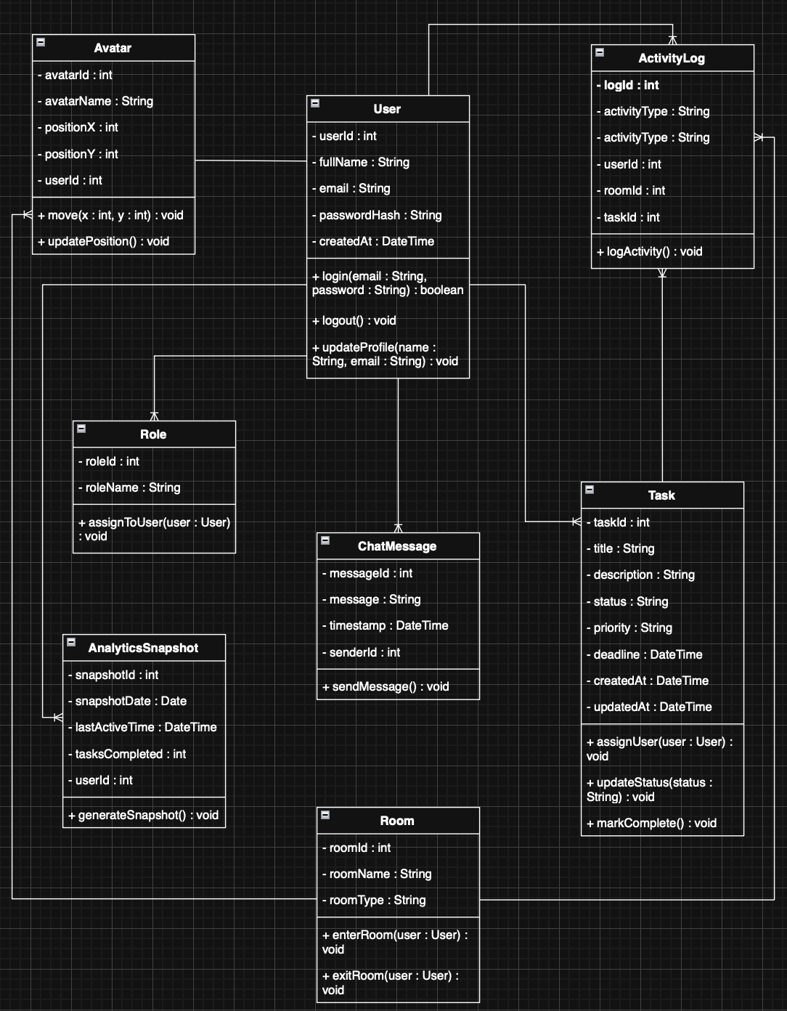

Sequence Diagrams

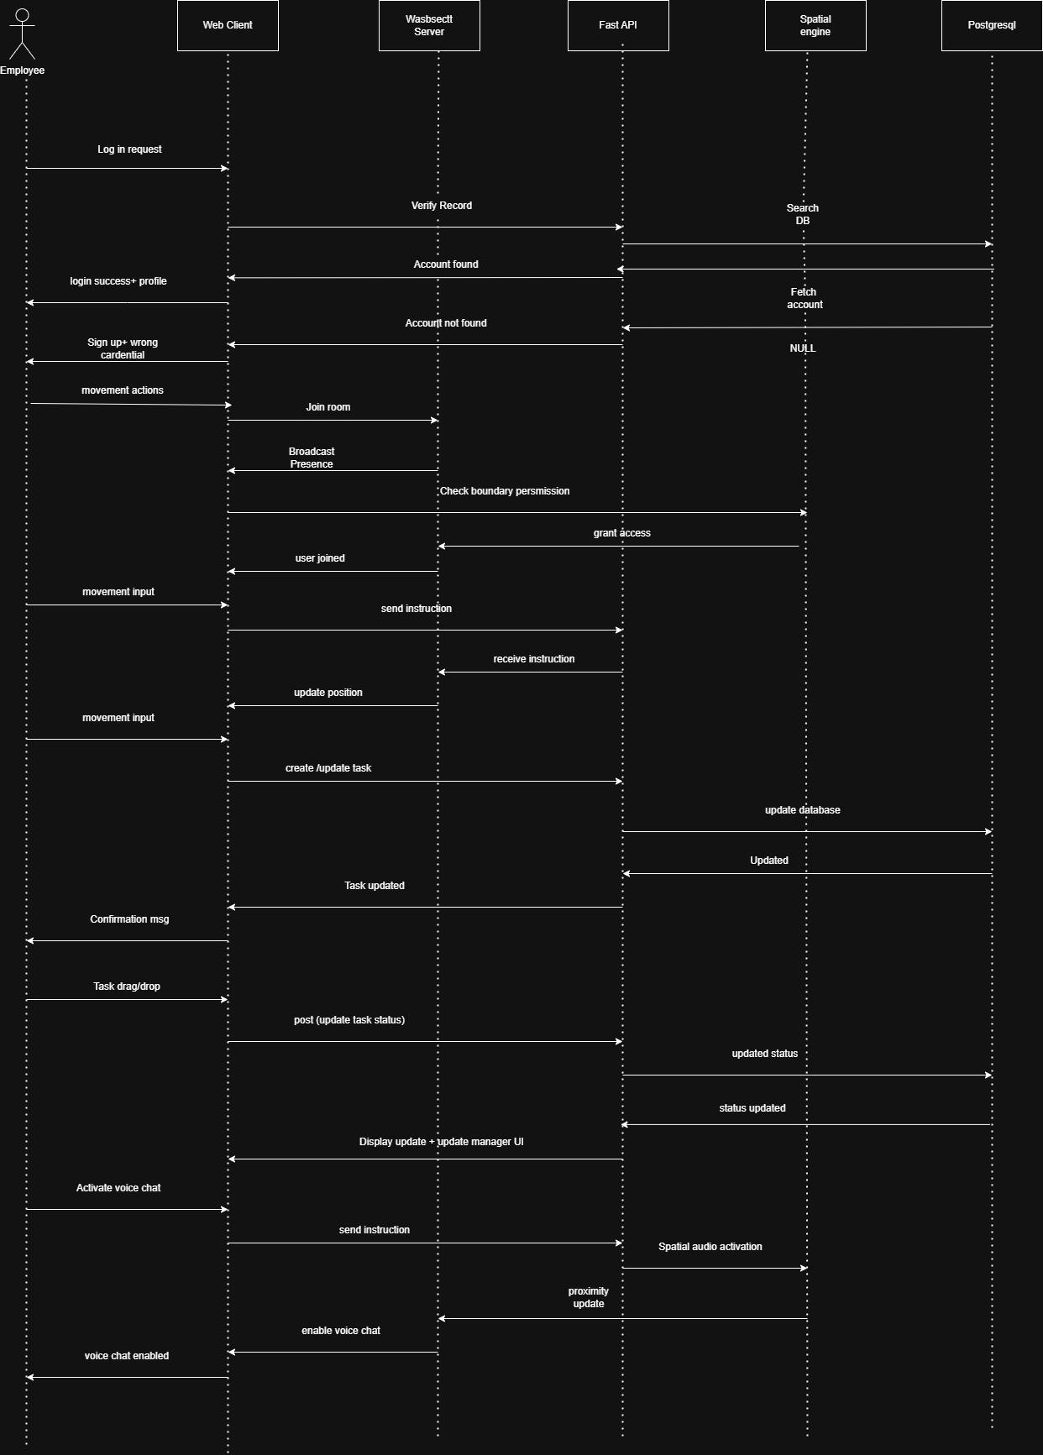

Collaboration Diagrams
- Manager
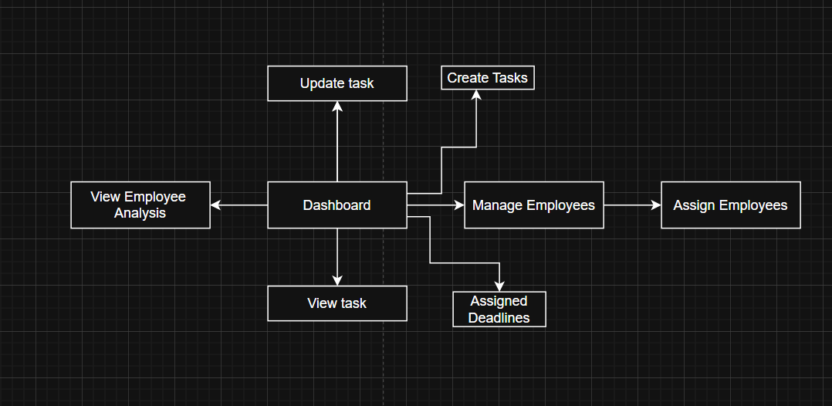
- Employee
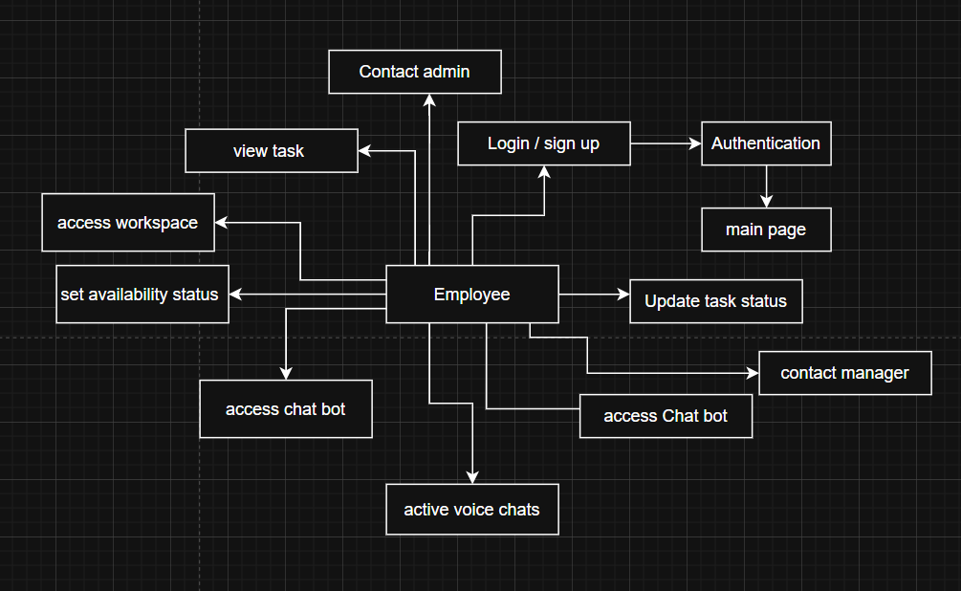

- Admin

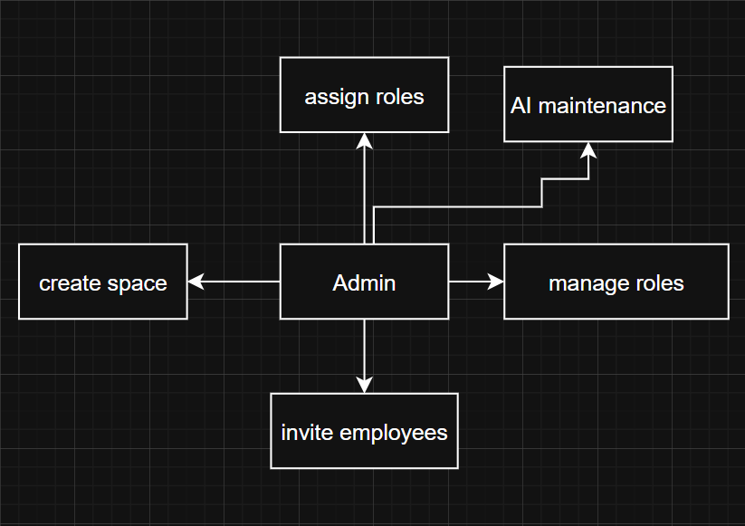
- System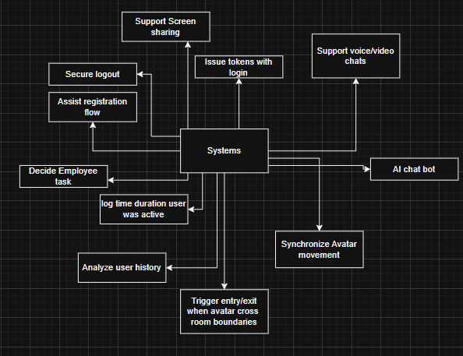

Other UMLs
Activity Diagram:
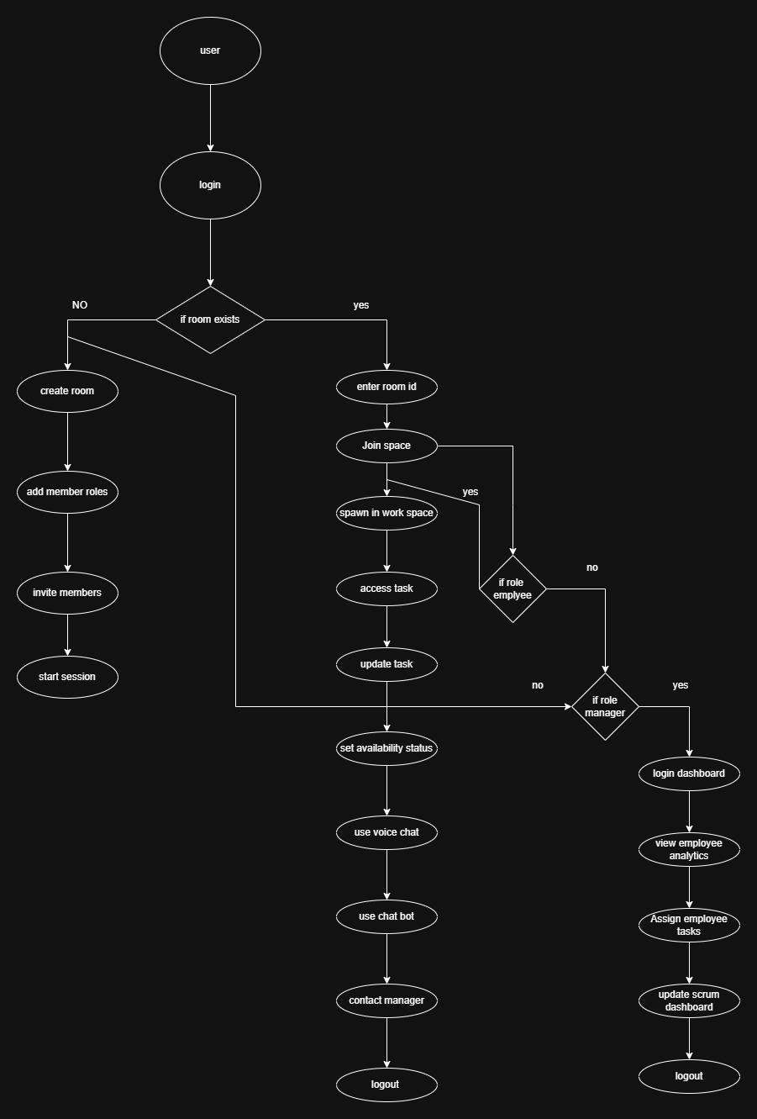

ERD
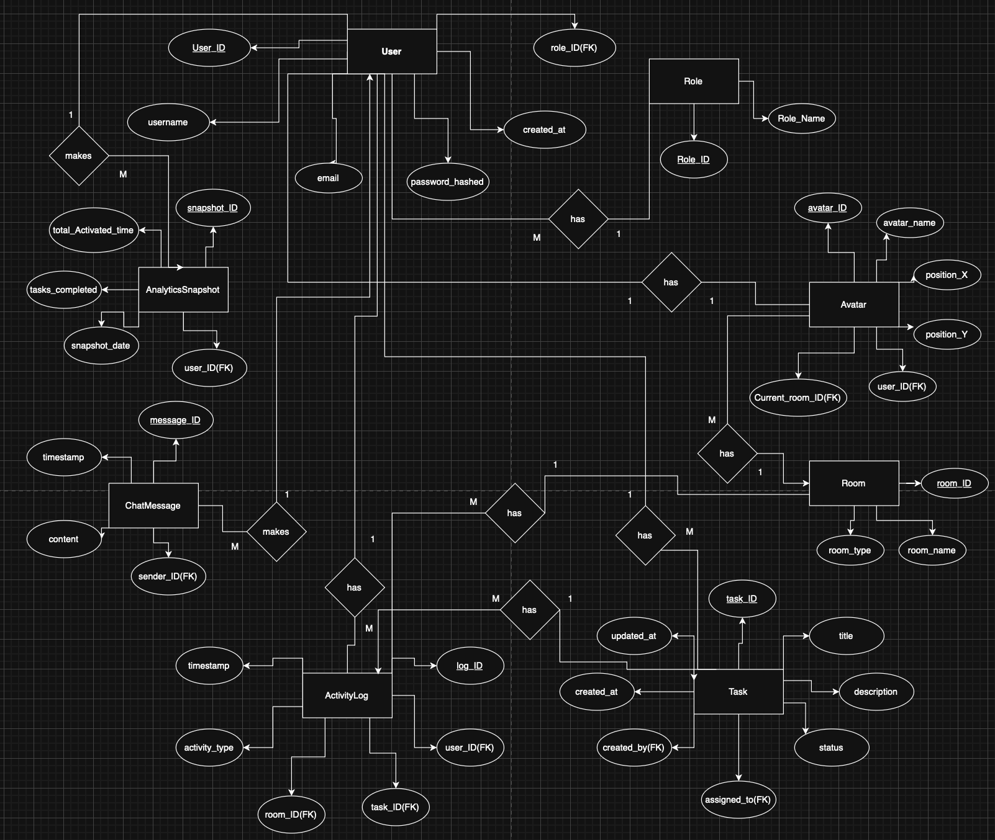

Data Dictionary
Sr no. | Element | Type | Validation | Mandatory | Description
1 | task_id | int | Unique | Yes | Unique task identifier
2 | title | string(100) | non_empty | yes | Task title
3 | description | text | optional | no | Detailed task status
4 | status | Enum | To-do /in progress/ Done | yes | Current task status
5 | created_at | Timestamp | system-generated | yes | Creation timestamp
6 | updated_at | Timestamp | system-generated | no | Last modification done
7 | log_id | int | unique | yes | Activity log identifier
8 | activity_type | string(50) | Predefined values | yes | Type of activity
9 | Time stamp | timestamp | system-generated | yes | Log time for the activity
10 | snapshot_id | Int | unique | yes | Analytics snapshot identifier
11 | Total activity time | int | >= 0 | yes | Total active time
12 | Task completed | int | >=0 | yes | Number of completed task
13 | snapshot_date | date | Valid date | yes | Date of analytics
14 | user_id | int | Auto, Unique | yes | Identification
15 | username | String | Not Null | yes | Screen name
16 | email | String | Valid Email | yes | identification
17 | password_hash | String | Encrypted | yes | password
18 | created_at | Timestamp | Not Null | yes | Timing
19 | role_id | int | Auto, Unique | yes | Identification
20 | role_name | String | Not Null | yes | Screen name
21 | avatar_id | int | Auto, Unique | yes | Identification
22 | avatar_name | String | Not Null | yes | Screen name
23 | position_x | float | >=0 | yes | X position
24 | position_y | float | >=0 | yes | Y position
25 | room_id | int | Auto, Unique | yes | Identification
26 | room_name | String | Not Null | yes | Screen name
27 | room_type | String | Predefined Vals | yes | Room Identification
28 | message_id | int | Auto, Unique | yes | Identification
29 | content | String | Not Null | yes | Msg Content
30 | timestamp | TimeStamp | Not Null | yes | Send Time

